

**DEPARTMENT OF ELECTRONICS AND COMMUNICATION ENGINEERING**

**Academic Year: 2023-24**

Microwave and Radiating Systems

21EC72

UG Laboratory Manual and Observation Book

(Autonomous scheme 2021)

**RV COLLEGE OF ENGINEERING®, Bengaluru-59**

***(Autonomous Institution affiliated to VTU, Belagavi)***

**Department of Electronics and Communication Engineering**

**SCHEME OF CONDUCT AND EVALUATION**

|  |  |
| --- | --- |
| **CLASS**: VII SEMESTER  **YEAR**: 2023-24 | **CIE MARKS** (Max): 50  **SEE MARKS** (Max): 50  **SEE**: 03 Hrs |

|  |  |  |  |  |  |  |
| --- | --- | --- | --- | --- | --- | --- |
| **Expt No** | **Title** | **Page No** | **Duration in Hrs** | **Max Marks** | **Marks obtained** | **Staff signature** |
| **Hardware (X-Band and C-Band) Experiments** | | | | | | |
| 1 | Study of Mode Curves of Reflex Klystron Source(X-band) | **1** | 2.5 | 10 |  |  |
| 2 | Radiation Characteristics of Pyramidal Horn Antenna and Microstrip Patch (X-band) | **6** | 2.5 | 10 |  |  |
| 3 | Characterization of Microwave Directional Coupler, Power divider, Hybrid coupler and Ring resonator (Strip line type, C-band) | **13** | 2.5 | 10 |  |  |
| 4 | Characterization of Microwave Magic Tee, Directional Coupler, Circulator, Tunable Attenuator and Isolator (Waveguide type, X-band) | **22** | 2.5 | 10 |  |  |
| 5 | Illustration of RADAR Range / Target Detection | **28** | 2.5 | 10 |  |  |
| **Design & Simulation Experiments in HFSS and Matlab** | | | | | | |
| 6 | Design simulation of micro strip line and and Hybrid Ring using HFSS | **33** | 2.5 | 10 |  |  |
| 7 | Design and Simulation of Rectangular Waveguide and Waveguide Magic-Tee and using HFSS | **41** | 2.5 | 10 |  |  |
| 8 | Design and Simulation of Patch Antenna and Optimetrics using HFSS | **83** | 2.5 | 10 |  |  |
| 9 | Performance Analysis of Rayleigh and Rician Fading Channel Models | **125** | 2.5 | 10 |  |  |
| 10 | Simulation of OFDM Transmission and Reception | **134** | 2.5 | 10 |  |  |
|  | **Total Record Marks Obtained** | | | **100** |  |  |
| **Demonstration** | | | | | | |
| 11 | Characterization of Lowpass, bandpass and band stop filters (C-Band) |  |  |  |  |  |
| 12 | Demonstration of Microwave Passive Devices and Antennas using Vector Network Analyzer |  |  |  |  |  |
| **Record Marks** | | | | **40** |  |  |
| **Lab Test** | | | | **10** |  |  |
| **Final Assessment** | | | | **50** |  |  |

**RV COLLEGE OF ENGINEERING®, Bengaluru-59**

***(Autonomous Institution affiliated to VTU, Belagavi)***

**Department of Electronics and Communication Engineering**



**Laboratory Certificate**

This is to certify that Mr. / Ms _________________________________ _________________________has satisfactorily completed the course of Experiments in Microwave and Radiating systems lab (18EC72) course prescribed by the Department during the year _____________

USN No.: ___________________ Semester: _________________

|  |  |
| --- | --- |
| Marks | |
| **Maximum** | **Obtained** |
| **50** |  |

|  |
| --- |
| Marks in words |
|  |

Signature of the staff in-charge Head of the Department

Date:

**Course Outcomes:**

**On completion of the course the student will be able to:**

1. Explain and summarize the working of transmission line, Waveguides, Microwave Passive Devices and Antennas.
2. Analyze wave propagation in transmission line, Waveguides and characterize the passive microwave components and Antennas.
3. Design the transmission lines, passive microwave components and Antennas for given specification and also match the impedance.
4. Evaluate S-Parameter, VSWR for transmission lines, Microwave components and radiation pattern for Antennas.

**CO-PO Mapping**

|  |  |  |  |  |  |  |  |  |  |  |  |  |
| --- | --- | --- | --- | --- | --- | --- | --- | --- | --- | --- | --- | --- |
|  | **PO1** | **PO2** | **PO3** | **PO4** | **PO5** | **PO6** | **PO7** | **PO8** | **PO9** | **PO10** | **PO11** | **PO12** |
| CO1 | H | M | H | M | L | M | M | - | L | L | - | M |
| CO2 | M | M | H | M | L | M | M | - | L | L | - | M |
| CO3 | H | M | H | M | L | M | M | - | L | L | - | M |
| CO4 | M | M | H | M | L | M | M | - | L | L | - | M |

**Rubrics for Evaluation**

|  |  |  |  |  |  |
| --- | --- | --- | --- | --- | --- |
| **Sl.No** | **Criteria** | **Excellent** | **Good** | **Average** | **Max Score** |
| **Data sheet** | | | | | |
| A | Problem statement | 9-10 | 6-8 | 1-5 | **10** |
| B | Design & specifications | 9-10 | 6-8 | 1-5 | **10** |
| C | Expected output | 9-10 | 6-8 | 1-5 | **10** |
| **Record** | | | | | |
| D | Simulation/ Conduction of the experiment | 14-15 | 11-13 | 1-10 | **15** |
| E | Analysis of the result. | 14-15 | 11-13 | 1-10 | **15** |
| **Viva** | | | | | **40** |
| **Total** | | | | | **100** |
| **Scale down to 10 marks** | | | | | |

**EXPERIMENT 1**

**Study of Mode Curves of Reflex Klystron Source**

**Topic Learning Objectives:**

The student must be able to:

1. Demonstrate the working of Reflex Klystron operating in X band.
2. Plot the modes of Reflex Klystron; determine parameters such as Transit time, Electronic tuning range, Sensitivity, Peak output power for different modes, and Frequency variation for any one mode.
3. Use reflex klystron as source for microwave devices such as antennas, waveguide Tee’s, couplers etc.
4. **AIM:** To conduct a suitable experiment on Reflex klystron to plot its mode curves and determine its Transit time, Electronic tuning range, Sensitivity, Peak output power for different modes and frequency variation for any one mode.
5. **EQUIPMENT REQUIRED:** Klystron power supply, Isolator, Frequency meter, Variable attenuator, X-band detector, Waveguide-to-BNC adaptor and CRO/ VSWR meter.
6. **THEORY:** Reflex klystron is a single cavity klystron that can operate in the frequency range of 1 to 25GHz and with an output power of up to 500mW. It is widely used in a local oscillator, in a microwave receiver of Doppler radars and missile systems. The principle behind a reflex klystron is that a fraction of the output power is feedback to the input cavity and if the loop gain has a magnitude of unity with a phase shift of multiple of 2π, then the klystron will oscillate.

The Repeller electrode is at a negative potential. It stops the movement of the electrons, turn them around, and send them back through the resonator gap. As the repelled electrons re-enter the resonator, they give up their kinetic energy. The field excited in the resonator adds in phase with the initial modulating field such that it reinforces the next wave of electron bunching. As a result, this energy serves as a regenerative feedback to sustain the oscillation at the resonant frequency of the resonator. This is the case only if the Repeller voltage is set such that the travel time, *to*, for the electrons to complete their travel through the gap, turn around, and back through the gap, satisfy the following condition:

 n = 1, 2, 3, (1.1)

Where *T* is the period of the RF waveform

If the voltage between the resonator and the Repeller is Vr, and the distance is d, the deceleration or retardation experienced by the electron may be expressed as

 (1.2)

Where ‘*e’* is charge of electron and ‘*m’* mass of electron. If an electron leaves the resonator with velocity *vo*, the displacement of the electron from the resonator, at any time *t*, is

 (1.3)

1. 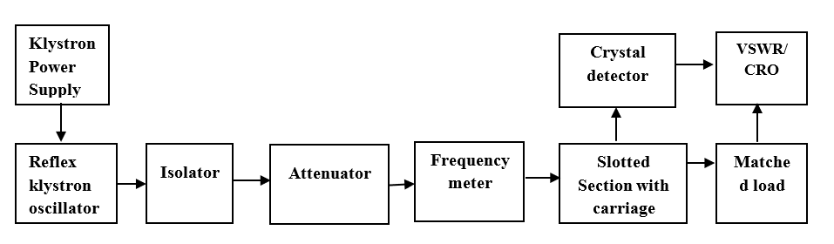**BLOCK DIAGRAM:**

**Fig 1.1: Experimental setup of a reflex klystron oscillator**

1. **PROCEDURE:**
2. Equipment’s are connected as shown in the Fig. 1.1.
3. Keep the repeller voltage knob at maximum (more negative), beam voltage knob at minimum before switching on power supply and switch on the fan.
4. Switch on klystron power supply and increase the beam voltage to 250V. Note down beam current.
5. Adjust the repeller voltage and detector knob to get maximum output on CRO/SWR meter keeping frequency meter detuned.
6. Repeller voltage is slowly reduced in steps of 5V and at each step note down the output voltage on CRO or output power on SWR meter along with frequency in frequency meter.
7. To measure operating frequency, the frequency meter is tuned to get the dip on the CRO and frequency is read directly from the frequency meter.
8. To find the guided wave length, move the carriage on the slotted line to get the maximum output and note down the reading on the scale on slotted line and Vernier scale, say d1 in cm. Move the carriage to the right or to the left to get the next maximum output position, say d2 in cm.

The guide wave length

= 2(d1 - d2) cm

1. Repeat step 6-7 note down the repeller voltage, power and frequency for different modes. Tabulate the readings.
2. Calculate the mode number, transit time of each mode, electronic tuning range and electronic tuning sensitivity. Sample calculation is shown in Appendix 1.
3. Plot the output power vs repeller voltage to get mode curves. Also plot the frequency vs repeller voltage. Expected graphs are shown in fig 1.2.
4. For dominant TE10 mode in rectangular waveguide λ0, λg and λc are related as below

$\frac{1}{{λ^{2}}_{0}}=\frac{1}{{λ^{2}}_{g}}+\frac{1}{{λ^{2}}_{c}}$---------------------------------------------- (1.1)

Where

$λ_{0}$, wavelength in free space in m

$λ_{g}$, guided wavelength in waveguide in m

$λ_{c}$, cut-off wavelength in waveguide in m

Measure the cut-off wavelength of TE10 mode by $λ_{c}$ =2a where a is broad dimension of waveguide

1. The guide wave length is = 2(d1 - d2) in m, From eqn 1, the $λ_{0}$ is calculated.

The operating frequency inside waveguide is $f_{0}=c/{λ_{0}}$ which can be verified by measured frequency in frequency meter.

1. **TABULAR COLUMN:**

|  |  |  |  |  |
| --- | --- | --- | --- | --- |
| SL.No. | Repeller voltage (V) | Power (dB) | Frequency meter reading (GHz). | Remarks |
|  |  |  |  |  |
|  |  |  |  |  |
|  |  |  |  |  |
|  |  |  |  |  |
|  |  |  |  |  |
|  |  |  |  |  |
|  |  |  |  |  |
|  |  |  |  |  |
|  |  |  |  |  |
|  |  |  |  |  |
|  |  |  |  |  |
|  |  |  |  |  |
|  |  |  |  |  |
|  |  |  |  |  |
|  |  |  |  |  |
|  |  |  |  |  |
|  |  |  |  |  |
|  |  |  |  |  |
|  |  |  |  |  |
|  |  |  |  |  |
|  |  |  |  |  |
|  |  |  |  |  |
|  |  |  |  |  |
|  |  |  |  |  |

**CAUTION**

*Even though there should be little danger from microwave radiation hazards in the lab, the following work habits are recommended whenever working with RF or microwave equipment:*

1. *Never look into the open end of a waveguide or transmission line that is connected to other equipment.*
2. *Do not place any part of your body against the open end of a waveguide or transmission line.*
3. ***Turn off the microwave power source when assembling or disassembling components.***



**Fig 1.2: Expected Mode curves of a klystron**

1. **RESULT**

|  |  |  |
| --- | --- | --- |
| **Mode No.** | **Case(1)** | **Case(2)** |
| Transit time |  |  |
| Electronic tuning Range |  |  |
| Electronic tuning sensitivity |  |  |

**Observations:**

|  |  |  |  |
| --- | --- | --- | --- |
| **Data sheet** | | | |
| 1 | Problem statement | 10 |  |
| 2 | Design & specifications | 10 |  |
| 3 | Expected output | 10 |  |
| **Record** | | | |
| 4 | Simulation/ Conduction of the experiment | 15 |  |
| 5 | Analysis of the result | 15 |  |
| 6 | Viva | 40 |  |
| 7 | Total | 100 |  |
| **Scale down to 10 marks** | | | |
| **Staff Signature:** | | | |

**EXPERIMENT 2**

**Radiation Characteristics of Pyramidal Horn Antenna and Microstrip Patch (X-band)**

**Topic Learning Objectives:**

The student must be able to:

1. Measure the radiation pattern of horn antenna in both principal planes
2. Determine the various parameters like Beamwidth, directivity
3. Apply Friss transmission formula to determine Gain of horn antenna
4. Compare theoretical values of Beamwidth, directivity and Gain with practical values
5. **AIM:** To measure the antenna parameters, Radiation pattern, determine half power beamwidth and directivity of Horn Antenna and carry out Gain measurements using method of comparison.
6. **EQUIPMENTS REQUIRED**: Klystron power supply, Isolator, Frequency meter, Variable attenuator, X-band detector, Horn antenna (2no’s), Waveguide-to-BNC adaptor and Oscilloscope, Power meter.
7. **THEORY:** Horn antenna is flared out or opened out waveguide whose main function is to produce a uniform phase wavefront with larger aperture compared to waveguide.

**Horn antennas were constructed as early as 1897 by J C Bose.**

The rectangular horn flares out of a rectangular or square waveguide with flat metal walls. Fig 3.1 shows the horn geometry; the pyramidal horn antennais fed from a rectangular waveguide of interior dimensions ‘*a’*and ‘*b’*. The aperture is of width ‘*A’*in the H-plane and height ‘*B’*in the E-plane.



**Fig 2.1: Overall geometry of Pyramidal horn antenna**

The Fig 3.2 (a, b) shows the Cross section through the xz-plane (H-plane), Cross section through the yz-plane (E-plane) respectively for Horn antenna. Where R1 ,R2 are axial length of horn antenna from throat to aperture in H-plane and E-plane respectively and *lh* and *le* are axial lengths in H-plane and E-plane respectively.



**Fig 2.3(b)**

Cross section through the yz-plane (E-plane).

**Fig 2.2(a)**

Cross section through the xz-plane (H-plane).

The normalized radiation pattern of Horn antenna

For H-Plane,

 Where (2.1)

For E-Plane 

Where  (2.2)

The half-power beamwidth relationship for the optimum horn is as follows

(for E-plane) (for H-plane) **(**2.3)

The gain of an optimum gain pyramidal horn is

 (2.4)

The Directivity of an optimum gain pyramidal horn is

 (2.5)

**MICROSTRIP PATCH ANTENNA:**

Microstrip patch antennas are low profile, conformable to planar and nonplanar surfaces, simple and inexpensive to manufacture using modern printed-circuit technology, mechanically robust when mounted on rigid surfaces, compatible with MMIC designs, and when the particular patch shape and mode are selected. They are very versatile in terms of resonant frequency, polarization, pattern, and impedance.

Microstrip patch antennas is analyzed using the transmission-line and cavity models. In the cavity model, a rectangular microstrip antenna can be represented as an array of two radiating narrow apertures (slots), each of width W and height h, separated by a distance L. The transmission-line model shown in Fig 2.4 represents the microstrip antenna by two slots, separated by a low-impedance Zc, transmission line of length L. The dimensions of the patch are finite along the length and width; the fields at the edges of the patch undergo fringing. This is illustrated along the length in Fig 2.4 for the two radiating slots of the microstrip antenna, same applies along the width. The amount of fringing is a function of the dimensions of the patch and the height of the substrate. For the principal E-plane (xy-plane) fringing is a function of the ratio of the length of the patch L to the height h of the substrate (L/h) and the dielectric constant *εr* of the substrate.



**Fig 2.4 Electric field lines across patch and ground plane for Microstrip line**

**Fig 2.4. Microstrip line**

The normalized radiation pattern of Microstrip patch antenna is

For E-Plane,

 (2.6)

For H-Plane,

 (2.7)

1. **BLOCK DIAGRAM:**



**Fig 2.5: Experimental setup for radiation pattern measurement**

1. **PROCEDURE:**
2. Experimental setup is shown in Fig 2.5. Switch on the Klystron power supply and adjust the beam voltage to 250V and keep the Repeller voltage knob to maximum position (More negative).
3. Connect the detector output to CRO and observe the square wave. Adjust the Repeller voltage, AM knob and slotted carriage to get maximum output on the CRO.
4. Note down the voltage on CRO and calculate corresponding power(Pt), or Connect the detector to power meter and measure the power in dBm
5. To find the operating frequency (f0) of horn antenna, tune the frequency meter till a dip in the square wave is observed. Read the corresponding frequency from the frequency meter; Also calculate operating wavelength(λ0)
6. Remove the detector and connect the transmitting horn antenna as shown in Fig 3.3. Set transmitting and receiving horn antennas in zero degree alignment separated by distance ≥(far field), where ‘D’ is the maximum dimension of Horn antenna.
7. Align both transmitting and receiving antennas in H-plane (co-polarization).
8. Rotate the receiving antenna in steps of 50 on both sides (clockwise and anticlockwise) and note down the corresponding power received (Pr) and tabulate the readings.
9. Using 90 deg – twister waveguide section, change the transmitting and receiving antenna to E-plane co-polarization.
10. Repeat step 7.
11. Plot the horn antenna radiation pattern for both E-plane and H-plane.
12. Determine half power Beamwidth using the plot of step 10; calculate Directivity using equation (3.5).
13. Calculate the theoretical values of half power Beamwidth using equation (3.3); calculate Gain, Directivity using equation (3.4), (3.5) respectively.
14. Mount the microstrip patch antenna (receiving antenna) on a rotatable stand.
15. Keep the distance between the two antennas sufficiently large such that they are in the far-field zone. Set the antennas for measurement in the E-plane.
16. Set the source to the frequency at antennas resonant frequency at which the radiation pattern is to be measured. Align the two antennas for maximum reading on the power meter. This is the peak position of the main beam. Note this power as the reference level say Pr at 00position.
17. The E-plane and H-plane orientations of microstrip patch and printed dipole antenna (Receiving antennas) with respect to transmitting horn antenna are shown in fig 3.5.
18. Rotate the test (receiving) antenna clockwise in small steps (5o or 10o) to 90o and note the readings on the power meter at every step (in tabular column).
19. Return to the 0o position. The power meter should read the reference level power. Repeat the measurements by rotating the antenna anti-clockwise in small steps till -90o and record the readings at every step. Plot the E-plane radiation pattern.
20. Repeat the measurements for the H-plane and plot the radiation pattern. Determine HPBW in both planes.
21. Calculate gain of an antenna from Friss transmission formula where Pt, λ0, and Pr are measured in step 3, 4, 7 respectively and R is separating distance between transmitter and receiver.
22. Expected radiation pattern of a pyramidal horn antenna is shown in Fig 2.6

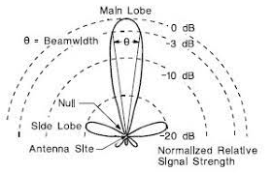

**Fig 2.6. Principal Plane patterns for optimum pyramidal horn / Patch antenna**



**Fig 2.7. Orientation for E- and H-plane of rectangular microstrip patch antenna and Horn antenna**

1. **Tabular column:**

|  |  |  |  |  |  |  |  |  |
| --- | --- | --- | --- | --- | --- | --- | --- | --- |
|  | **HORN antenna** | | | | **PATCH Antenna** | | | |
| **Power in E plane** | | **Power in H plane** | | **Power in E plane** | | **Power in H plane** | |
| **Angle (degrees)** | **Left** | **Right** | **Left** | **Right** | **Left** | **Right** | **Left** | **Right** |
| **0­** |  |  |  |  |  |  |  |  |
| **5** |  |  |  |  |  |  |  |  |
| **10** |  |  |  |  |  |  |  |  |
| **15** |  |  |  |  |  |  |  |  |
| **20** |  |  |  |  |  |  |  |  |
| **25** |  |  |  |  |  |  |  |  |
| **30** |  |  |  |  |  |  |  |  |
| **35** |  |  |  |  |  |  |  |  |

**RESULT**

|  |  |  |
| --- | --- | --- |
| **Parameters** | **HORN Antenna** | **PATCH Antenna** |
| The transmitted power (Pt) |  |  |
| The Operating frequency |  |  |
| The Operating wavelength |  |  |
| The separating distance between transmitter and receiver (R) |  |  |
| The received power (Pr) |  |  |
| **Antenna Parameters** | **Theoretical** | **Practical** |
| Half power Beamwidth() |  |  |
| Half power Beamwidth() |  |  |
| Gain |  |  |
| Directivity |  |  |

**Basic precautions to be taken:**

1. Power flowing out of horn antenna may damage the retina of the eye**, do not see directly inside the horn antenna.**
2. Materials present in the vicinity of the experimental setup may be absorbing ones. Keep reflecting objects away from the experimental setup.

**Observations:**

|  |  |  |  |
| --- | --- | --- | --- |
| **Sl.No** | **Criteria** | Max Marks | Marks obtained |
| **Data sheet** | | | |
| 1 | Problem statement | 10 |  |
| 2 | Design & specifications | 10 |  |
| 3 | Expected output | 10 |  |
| **Record** | | | |
| 4 | Simulation/ Conduction of the experiment | 15 |  |
| 5 | Analysis of the result | 15 |  |
| 6 | Viva | 40 |  |
| 7 | Total | 100 |  |
| **Scale down to 10 marks** | | | |
| **Staff Signature:** | | | |

**EXPERIMENT 3**

**Characterization of Ring Resonator, Power Divider, Directional Coupler and Hybrid Ring**

**(Strip line type, C-band)**

**Topic Learning Objectives:**

The student must be able to:

1. Characterize microwave devices (strip-line type) such as ring resonator, power divider, directional coupler and hybrid coupler.
2. Determine the various parameters like power division, isolation and insertion loss etc.

**1.AIM:** To characterize the microwave passive components at C-band range of frequencies.

**2.EQUIPMENTS REQUIRED:** RF Signal source, power meter/VSWR meter, ring resonator, power divider, directional coupler and hybrid coupler.

**3.THEORY:**

**Ring resonator**

The ring resonator is known as a simple printed resonator that is useful for making approximate measurement of dielectric constant. Additionally, it is used in filters, and to an extent in antennas. In principle it is a simple structure, but accurate analysis of a ring resonator is difficult because of the input and output coupling to straight microstrip printed lines. Two structures shown in Fig 3.1 are reported in the literature.

Looking at a ring resonator in isolation, it may appear that the field would be in the form of a wave circulating around in either direction, but in reality, the coupling structure plays a very important role. It may be noticed that both the structures are symmetrical. It follows that whatever voltage wave is excited in the clockwise direction, an identical voltage wave will be excited in the anti-clockwise direction as well. This gives rise to the standing wave pattern, common to resonators. The voltage maxima in both cases are located at the center of the coupled section. Looking at this behavior, it may be more accurate to look upon the ring resonator as two half-wave transmission line resonators (open ended) connected in parallel. The coupling structures disturb these open ends and shift the resonant frequency slightly.

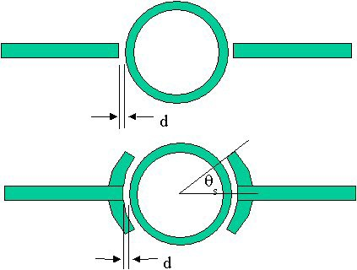

**Fig 3.1. Ring resonator coupled with (a) open-ended lines and (b) with coupling arcs**

**Fig. 3.2 Microstrip Ring Resonator Circuit mounted in the test jig**

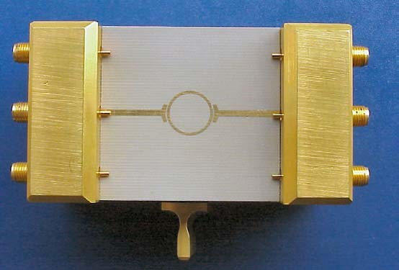

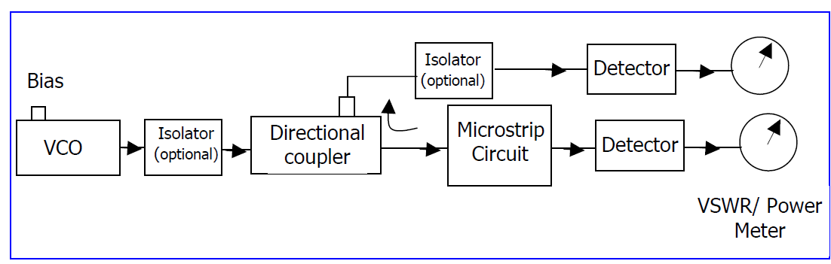

**Fig. 3.3 Measurement setup based on Voltage Controlled Oscillator (VCO)**

# PROCEDURE:

To measure return and insertion loss characteristics of the microstrip ring resonator and determine the resonant frequency and insertion loss at the resonant frequency. Pick up the Microstrip Ring Resonator circuit board from the AMTK and mount the substrate in the test jig as shown in Fig 3.2. Here we use only the center pair of input/output SMA connectors. The circuit is now ready for testing.

1. Set up the system as shown in Fig 3.3.
2. Measure the input power fed to the Microstrip ring resonator circuit at a selected VCO frequency.
3. Measure the reflected power by noting the reading of the detector connected to the directional coupler and the forward power by noting the reading of the detector connected to the Microstrip ring resonator circuit (DUT) at the same frequency settings of the VCO.
4. Repeat the above two steps at 5-10 different frequencies by tuning the VCO.
5. Plot the transmission loss of the microstrip ring resonator.
6. From the plot, determine the resonant frequency of the microstrip ring resonator. From this, knowing that ring length= λg, calculate the effective dielectric constant and the permittivity of the substrate used. This should be 3.2.

**Tabular column:**

|  |  |  |
| --- | --- | --- |
| **Sl No** | **Frequency (GHz)** | **Received power (dB)** |
|  |  |  |
|  |  |  |
|  |  |  |
|  |  |  |
|  |  |  |
|  |  |  |
|  |  |  |
|  |  |  |
|  |  |  |
|  |  |  |

**Expected result:**



**Power divider:**

The layout of a conventional T-junction power divider in microstrip configuration with input port matched is shown in Fig 3.4.

**Fig. 3.4 Layout of a conventional T-junction Power Divider**

The scattering parameters of this type of T-junction power divider is given by:



Applying unitary conditions, we get

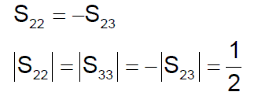

This clearly shows that it is impossible to match all the three ports of this type of power divider. The layout of the modified power divider (Known as the Wilkinson power divider) in which all the three ports are perfectly matched at the centre frequency is shown in Fig 3.5. An isolation resistance of 2Z0 is added between ports 2 and 3.



**Fig. 3.5 Layout of the modified T-junction Power Divider**

The scattering parameters of the modified power divider at center frequency are given by



It is interesting to note that all the ports are simultaneously matched. Ports 2 and 3 are also perfectly isolated. This type of power divider can be used as power combiner as well. Power fed to ports 2 and 3 simultaneously gives entire power at port 1.

**Procedure:**

For input power fed to port 1 of the power divider, measure power coupled to ports 2 and 3 with and without the isolation resistor. Determine return loss, power split and isolation at the centre frequency for the two cases. Also, determine 20-dB isolation bandwidth for the Wilkinson power divider

1. Pick up the Microstrip power divider circuit board (without the resistor) from the **AMTK** and mount the substrate in the test jig as shown in Fig 3.6. Here, we use the middle SMA connector for connecting the input and outer two SMA connectors for connecting the two output ports. The circuit is now ready for testing.
2. Set up the system as shown in Fig 3.3. Terminate port 3 in 50-ohm matched load. Measure the input power fed to port 1 of the Microstrip power divider circuit at a selected VCO frequency. Measure the reflected power by noting the reading of the detector connected to the directional coupler and the forward power by noting the reading of the detector connected to port 2 of the microstrip power divider circuit (DUT) shown in Fig 3.6 at the same frequency settings of the VCO.
3. Repeat the above two steps at 5-10 different frequencies by tuning the VCO.
4. Plot the power coupled to port 2 of the microstrip power divider circuit.
5. Using the same procedure, plot power coupled to port 3 (Match terminate port 2).
6. Terminate port 1 and feed power to port 2 and measure power available at port 3.
7. Now terminate port 1 with matched load and measure isolation between ports 2 and 3.
8. Determine the power split and isolation at the centre frequency.



**Fig. 3.6 Microstrip power divider circuit without resistor in the test jig**

**Tabular column:**

|  |  |  |  |  |
| --- | --- | --- | --- | --- |
| **Sl No** | **Frequency (GHz)** | **Received power (dB) in P2, Match P3, P1=input** | **Received power (dB) in P3, Match P2, P1=input** | **Received power (dB) in P3, Match P1, P2=input** |
|  |  |  |  |  |
|  |  |  |  |  |
|  |  |  |  |  |
|  |  |  |  |  |
|  |  |  |  |  |
|  |  |  |  |  |
|  |  |  |  |  |

**Expected result:**



**Parallel Coupled Directional Coupler**

The layout of a parallel-coupled directional coupler in microstrip configuration is shown in Fig 3.7.



**Fig. 3.7 Layout of a parallel-coupled directional coupler**

The mean length ‘*l*’ of the coupled line section is quarter wavelength λ0/4 in the transmission medium at the center frequency f0 . All input and output lines have the same characteristic impedance Z0(=1/Y0). With port 1 as the input port, port 2 is the coupled port, port 4 is the direct-coupled port and port 3 is the isolated port.

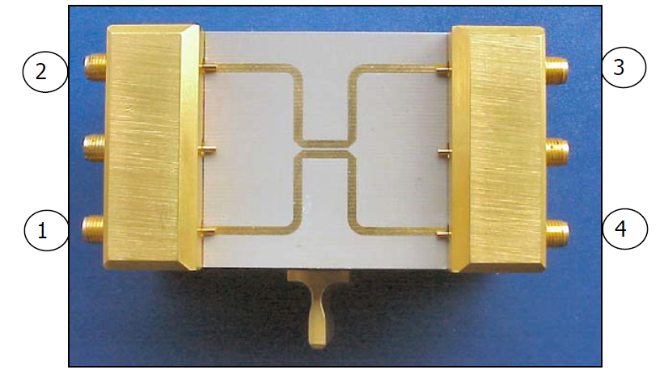

**Fig. 3.8 Microstrip parallel-coupled directional Coupler mounted in the test jig**

**Procedure:**

For input power fed to port 1 of the parallel-coupled directional coupler, measure power coupled to ports 2, 3 and 4. Determine return loss, coupling, isolation and directivity at the centre frequency. Also determine bandwidth over which coupling is 15±1 dB.

1. Pick up the Microstrip parallel-coupled directional coupler circuit board from the **AMTK** and mount the substrate in the test jig as shown in Fig 3.8. Here we use the outer two pairs of input/output SMA connectors. The circuit is now ready for testing.
2. Set up the system as shown in Fig 3.3.
3. Terminate ports 3 and 4 in 50-ohm matched loads.
4. Measure the input power fed to port 1 of the Microstrip parallel-coupled directional coupler circuit at a selected VCO frequency.
5. Measure the reflected power by noting the reading of the detector connected to the directional coupler and the forward power by noting the reading of the detector connected to port 2 of the microstrip parallel-coupled directional coupler circuit (DUT) at the same frequency settings of the VCO.
6. Find the power coupled to port 2 of the microstrip parallel-coupled directional coupler circuit.
7. Using the same procedure, find power coupled to port 3 (Matched terminate ports 2 and 4) and port 4 (matched terminate ports 2 and 3)
8. Determine insertion loss, coupling and isolation at the centre frequency.

Various parameters of the coupling are given by:

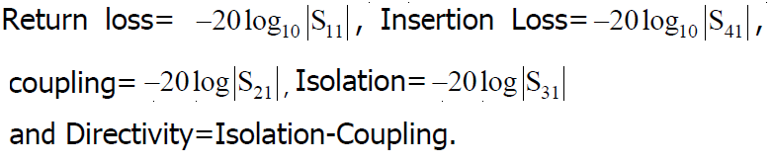

**Result:**

|  |  |
| --- | --- |
| **Sl No** | **Parameter(dB)** |
| 1 | Insertion loss = |
| 2 | Coupling = |
| 3 | Isolation = |
| 4 | Directivity = |

**Hybrid Coupler:**

Theory: The layout of a rat race hybrid coupler in microstrip configuration is shown in Fig 3.9.

|  |  |
| --- | --- |
|  |  |

**Fig. 3.9: a) Layout of a rat race hybrid coupler b) Microstrip Rat Race Hybrid Coupler Circuit mounted in the test jig**

The mean length ‘l’ of three branches is quarter wavelength λ0/4 in the transmission medium at the center frequency f0, whereas, one of the branches is 3λ0/4 long. Za(=1/Ya) and Zb(=1/Yb) denote the characteristic impedances of the branches as shown in the layout. All input and output lines have the same characteristic impedance Z0(=1/Y0). The rat-race hybrid coupler can be used as power divider as well as a power combiner. With port 2 as the input port, equal phase and amplitude signals emerge from ports 1 and 4 and port 3 is isolated. With port 1 as the input port, equal amplitude signals emerge from ports 2 and 3 and port 4 is isolated. These signals have 1800 phase shift. When used as a power combiner, signals are fed to ports 2 and 3. Difference signal is available at port 4 (Δ−port) and the sum signal is available at port 1 (Σ-port).

**Procedure:**

Pick up the Microstrip Rat Race Hybrid Coupler circuit board from the AMTK and mount the substrate in the test jig as shown in Fig 3.10. Here we use top two pairs of input/output SMA connectors. The circuit is now ready for testing.

1. Set up the system as shown in Fig 3.3.
2. Terminate ports 3 and 4 in 50-ohm matched loads.
3. Measure the input power fed to port 1 of the Microstrip rat race hybrid coupler circuit at a selected VCO frequency.
4. Measure the reflected power by noting the reading of the detector connected to the directional coupler and the forward power by noting the reading of the detector connected to port 2 of the Microstrip rat race hybrid coupler circuit (DUT) at the same frequency settings of the VCO.
5. Determine the power coupled to port 2 of the microstrip rat race hybrid coupler circuit.
6. Using the same procedure, find the power coupled to port 3 (Match terminate ports 2 and 4) and port 4 (match terminate ports 2 and 3).

**Result:**

|  |  |
| --- | --- |
| **Sl No** | **Parameter(dB)** |
| 1 | Insertion loss = |
| 2 | Coupling = |
| 3 | Isolation = |

**Observations:**

|  |  |  |  |
| --- | --- | --- | --- |
| **Sl.No** | **Criteria** | Max Marks | Marks obtained |
| **Data sheet** | | | |
| 1 | Problem statement | 10 |  |
| 2 | Design & specifications | 10 |  |
| 3 | Expected output | 10 |  |
| **Record** | | | |
| 4 | Simulation/ Conduction of the experiment | 15 |  |
| 5 | Analysis of the result | 15 |  |
| 6 | Viva | 40 |  |
| 7 | Total | 100 |  |
| **Scale down to 10 marks** | | | |
| **Staff Signature:** | | | |

**EXPERIMENT 4**

**Characterization of Microwave Magic Tee, Directional Coupler, Circulator, Tunable Attenuator and Isolator (Waveguide type, X-band)**

**Topic Learning Objectives:**

The student must be able to:

1. Demonstrate the working of microwave devices such as waveguide Magic Tee, Circulator, Directional Coupler, Attenuator and Isolator.
2. Determine the S parameters and losses such as isolation, insertion loss and directivity of microwave devices such as waveguide Magic Tee, Circulator, Directional Coupler, Attenuator and Isolator.
3. **AIM:** To determine S-parameters and plot S- matrix for passive microwave devices such as waveguide E-plane Tee, H-plane Tee, Magic Tee, Circulator, Directional Coupler and Isolator.
4. **EQUIPMENTS REQUIRED:** Klystron power supply, klystron oscillator, Isolator, Attenuator, Frequency meter, E-plane Tee, H-plane Tee, Magic tee, Circulator, Directional Coupler, Isolator, crystal detector, VSWR/Power meter/CRO and Matched load.
5. **THEORY:**

**Magic Tee**

A magic tee is a combination of E-plane and H-plane tee and is shown in fig 4.1.



**Fig 4.1: Structure of a Magic Tee**

The characteristics of magic tee are:

1. If two waves of equal magnitude and same phase are fed into port 1 and port 2 the output will be zero at port 3 and additive at port 4.
2. If a wave is fed into port 4 it will be divided equally between port 1 and port 2 of the collinear arms and will not appear at port 3.
3. If a wave is fed into port 3 , it will produce an output of equal magnitude and opposite phase at port 1 and port 2. the output at port 4 is zero.
4. If a wave is fed into one of the collinear arms at port 1 and port 2, it will not appear in the other collinear arm at port 2 or 1 because the E-arm causes a phase delay while H arm causes a phase advance.

S-matrix of a Magic tee is given by



**Applications of E-H Plane Tee**

Some of the most common applications of E-H Plane Tee are as follows:

1. E-H Plane junction is used to measure the impedance − A null detector is connected to E-Arm port while the Microwave source is connected to H-Arm port. The collinear ports together with these ports make a bridge and the impedance measurement is done by balancing the bridge.
2. E-H Plane Tee is used as a duplexer − A duplexer is a circuit which works as both the transmitter and the receiver, using a single antenna for both purposes. Port 1 and 2 are used as receiver and transmitter where they are isolated and hence will not interfere. Antenna is connected to E-Arm port. A matched load is connected to H-Arm port, which provides no reflections. Now, there exists transmission or reception without any problem.
3. E-H Plane Tee is used as a mixer − E-Arm port is connected with antenna and the H-Arm port is connected with local oscillator. Port 2 has a matched load which has no reflections and port 1 has the mixer circuit, which gets half of the signal power and half of the oscillator power to produce IF frequency.

**Directional coupler**

Directional coupler shown in Fig 4.2. Directional coupler is a device that samples a small amount of Microwave power for measurement purposes. The power measurements include incident power, reflected power, VSWR values, etc. Directional Coupler is a 4-port waveguide junction consisting of a primary main waveguide and a secondary auxiliary waveguide. The following Fig shows the image of a directional coupler.

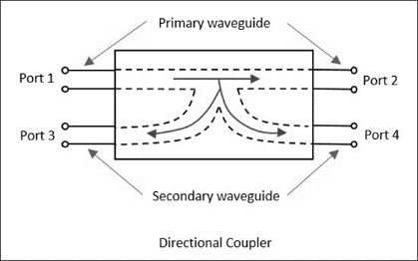

**Fig4.2: Directional coupler**

The properties of an ideal directional coupler are as follows.

1. All the terminations are matched to the ports.
2. When the power travels from Port 1 to Port 2, some portion of it gets coupled to Port 4 but not to Port 3. As it is also a bi-directional coupler, when the power travels from Port 2 to Port 1, some portion of it gets coupled to Port 3 but not to Port 4.
3. If the power is incident through Port 3, a portion of it is coupled to Port 2, but not to Port 1.
4. If the power is incident through Port 4, a portion of it is coupled to Port 1, but not to Port 2.
5. Port 1 and 3 are decoupled as are Port 2 and Port 4.

Ideally, the output of Port 3 should be zero. However, practically, a small amount of power called back power is observed at Port 3. The following Fig indicates the power flow in a directional coupler.

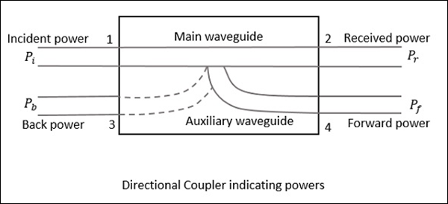

Where

Pi = Incident power at Port 1

Pr = Received power at Port 2

Pf = Forward coupled power at Port 4

Pb = Back power at Port 3

Following are the parameters used to define the performance of a directional coupler.

### Coupling Factor (C)

The Coupling factor of a directional coupler is the ratio of incident power to the forward power, measured in dB.

C=10log10(Pi/Pf) dB

**Directivity (D)**

The Directivity of a directional coupler is the ratio of forward power to the back power, measured in dB.

D=10log10(Pf/Pb) dB

**Isolation**

It defines the directive properties of a directional coupler. It is the ratio of incident power to the back power, measured in dB.

I=10log10(Pi/Pb) dB

Isolation in dB = Coupling factor + Directivity

**BLOCK DIAGRAM:**

Reflex klystron oscillator

oscillator

Isolator

Matched load

Matched load

VSWR/ CRO

DUT

Crystal detector

Attenuator

Frequency Meter

Klystron

Power

Supply

**Fig 4.3: Experimental setup for determining S-matrix for passive devices.**

1. **Procedure:**

**Magic Tee**

1. Equipment’s are connected as shown in the Fig 4.3.
2. Keep the repeller voltage at maximum, beam voltage at minimum before switching on power supply and also switch on the fan.
3. Switch on klystron power supply and increase the beam voltage to 250V. Note down beam current.
4. Adjust the repeller voltage and detector knob to get maximum output (Pi) on CRO/SWR meter keeping frequency meter detuned.
5. Feed the microwave power at the given port and measure the output power at the required port using the CRO while terminating the other ports with matched loads.
6. The readings are noted and the parameters like insertion loss, isolation and power division are calculated using necessary equations.
7. The input power to any given can be measured by removing the magic tee and connecting the crystal detector and CRO.

**Directional Coupler**

1. The experimental set up is as shown in Fig 4.3.
2. Energize the microwave source for particular frequency of operation.
3. Set any reference level of power on CRO/SWR meter, and note the reading (reference level let P1).
4. Measure the power in different ports and calculate coupling, directivity and isolation.

**Results:**

**S-matrix of a magic tee:**

|  |  |  |
| --- | --- | --- |
| **Sl No** | **Parameter** | **Value (dB)** |
| 1 | S31=S32 |  |
| 2 | S41=S42 |  |
| 3 | S34=S43 |  |

**S-matrix of a Directional Coupler**

|  |  |  |
| --- | --- | --- |
| **Sl No** | **Parameter** | **Value (dB)** |
| 1 | S12 |  |
| 2 | S21 |  |
| 3 | S32 |  |

**CIRCULATOR AND ISOLATOR**

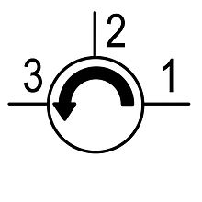**THEORY:** A circulator is a ferrite device (ferrite is a class of materials with strange magnetic properties) with usually three ports circulators are [non-reciprocal](http://www.microwaves101.com/encyclopedia/Network_theory.cfm) devices, that is, energy into port 1 predominantly exits port 2, energy into port 2 exits port 3, and energy into port 3 exits port 1. In a reciprocal device the same fraction of energy that flows from port 1 to port 2 would occur to energy flowing in the opposite direction, from port 2 to port 1. The [scattering matrix](http://en.wikipedia.org/wiki/Scattering_parameters) for an ideal three-port circulator is

|  |  |
| --- | --- |
| $$\left[S\right]=\left[\begin{matrix}0 & 0 & 1 \\ 1 & 0 & 0 \\ 0 & 1 & 0\end{matrix}\right]$$ |  |
| **S-Matrix of Circulator** | **Fig 4.4: Circulator** |

An isolator is a [two-port](http://en.wikipedia.org/wiki/Two-port_network) device that transmits [microwave](http://en.wikipedia.org/wiki/Microwave) or [radio frequency](http://en.wikipedia.org/wiki/Radio_frequency) power in one direction only. It is used to shield equipment on its input side, from the effects of conditions on its output side; for example, to prevent a microwave source being detuned by a mismatched load. An isolator is a non-[reciprocal](http://en.wikipedia.org/wiki/Reciprocity_(electromagnetism)) device, with a non-[symmetric](http://en.wikipedia.org/wiki/Symmetric_matrix) [scattering matrix](http://en.wikipedia.org/wiki/Scattering_parameters). An ideal isolator transmits all the power entering port 1 to port 2, while absorbing all the power entering port 2, its S-matrix is

|  |  |
| --- | --- |
| $$\left[S\right]=\left[\begin{matrix}0 & 0 \\ 1 & 0\end{matrix}\right]$$ |  |
| **S-Matrix** | **Fig 4.5: Isolator** |

**PROCEDURE:**

1. Connect the components as shown in experimental set up Fig 4.3.
2. Structure of a circulator and isolator are shown in the Fig 4.4 and Fig 4.5 respectively.
3. Energize the microwave source for particular frequency of operation.
4. With the help of variable attenuator and gain control knob of VSWR meter set any power level in the CRO/SWR meter.
5. Verify the s-matrix for both circulator, isolator and attenuator.

**RESULT**

**S-matrix of a Circulator:**

|  |  |  |
| --- | --- | --- |
| Sl No | Parameter | Value (dB) |
| 1 | S13 |  |
| 2 | S21 |  |
| 3 | S32 |  |

S12=S23=S31=0 (To verify)

**S-matrix of a Isolator:**

|  |  |  |
| --- | --- | --- |
| Sl No | Parameter | Value (dB) |
| 1 | S12 |  |
| 2 | S21 |  |

**S-matrix of a Attenuator:**

|  |  |  |
| --- | --- | --- |
| Sl No | Parameter | Value (dB) |
| 1 | S12 |  |
| 2 | S21 |  |

**Observations:**

|  |  |  |  |
| --- | --- | --- | --- |
| **Sl.No** | **Criteria** | Max Marks | Marks obtained |
| **Data sheet** | | | |
| 1 | Problem statement | 10 |  |
| 2 | Design & specifications | 10 |  |
| 3 | Expected output | 10 |  |
| **Record** | | | |
| 4 | Simulation/ Conduction of the experiment | 15 |  |
| 5 | Analysis of the result | 15 |  |
| 6 | Viva | 40 |  |
| 7 | Total | 100 |  |
| **Scale down to 10 marks** | | | |
| **Staff Signature:** | | | |

**EXPERIMENT 5**

**Illustration of RADAR Range / Target Detection**

**Topic Learning Objectives:**

The student must be able to:

1. Perform radar range direction detection through horn antenna.
2. Compute the Radar Cross Section (RCS) for the target object.
3. **AIM:** To compute the range and object detection using X-band horn antenna transmitter and receiver with different Radar Cross Section (RCS).
4. **EQUIPMENTS REQUIRED:** Klystron power supply, Isolator, Frequency meter, Variable attenuator, X-band detector, Horn antenna (2No’s), Metal plates (2 Nos) with different RCS, Waveguide-to-BNC adaptor and Oscilloscope, Power meter.
5. **THOERY:**

Radar is a radiolocation system that uses radio waves to determine the distance , angle , and radial velocity of objects relative to the site. It is used to detect and track aircraft, ships, spacecraft, guided missiles, and motor vehicles, and map weather formations, and terrain.

The modern uses of radar are highly diverse, including air and terrestrial traffic control, radar astronomy, air-defense systems, anti-missile systems, marine radars to locate landmarks and other ships, aircraft anti-collision systems, ocean surveillance systems, outer space surveillance and rendezvous systems, meteorological precipitation monitoring, radar remote sensing, altimetry and flight control systems, guided missile target locating systems, self-driving cars, and ground-penetrating radar for geological observations. Modern high tech radar systems use digital signal processing and machine learning and are capable of extracting useful information from very high noise levels.

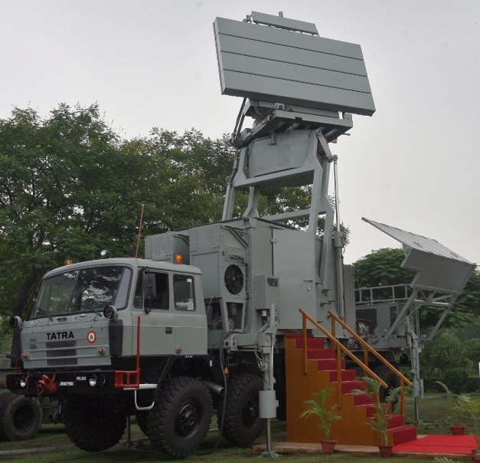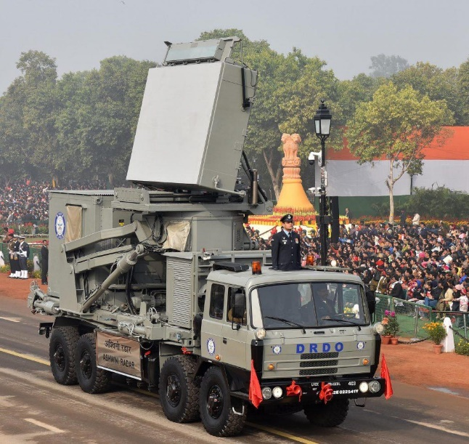

**Fig 5.1 Different types of Radar used in surveillances and other applications. Courtesy: Indian army & DRDO**

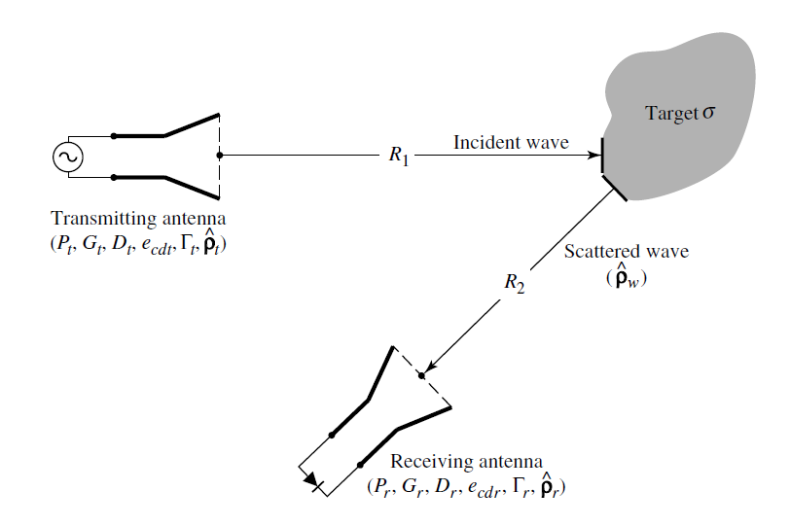

**Fig 5.2 Geometrical arrangement of transmitter, target, and receiver for radar (Courtesy: Antenna Theory Analysis and Design, Constantine A. Balanis)**

the radar cross section or echo area (σ ) of a target which is defined as the area intercepting that amount of power which, when scattered isotopically, produces at the receiver a density which is equal to that scattered by the actual target

The amount of power delivered to the receiver load is given by

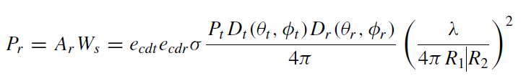. (5.1)

Where Ar is the effective area of the receiving antenna

The received power to the input power is

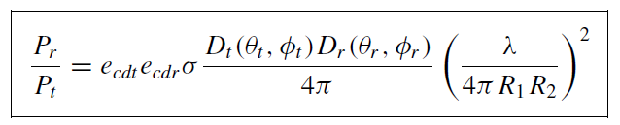(5.2)

If the losses included, then the received power to the input become,

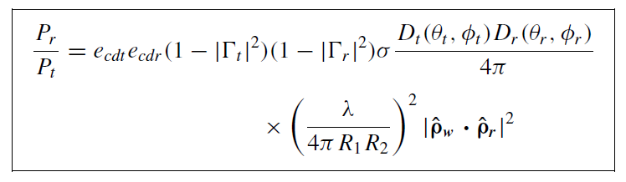(5.3)

For polarization-matched antennas aligned for maximum directional radiation and reception, the received power is,

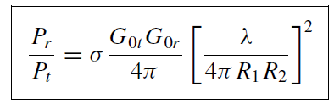 (5.4)

1. **BLOCK DIAGRAM:**

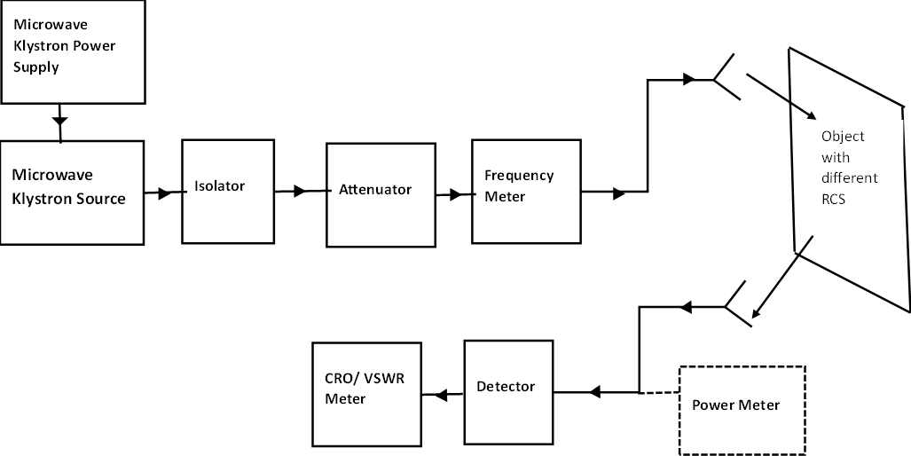

**Fig 5.5 Experimental setup to target detection and calculate the radar cross section area**

**PROCEDURE:**

1. Experimental setup is shown in Fig 5.5. Switch on the Klystron power supply and adjust the beam voltage to 250V and keep the Repeller voltage knob to maximum position (More negative).
2. Connect the detector output to CRO and observe the square wave. Adjust the Repeller voltage, AM knob and slotted carriage to get maximum output on the CRO.
3. Note down the voltage on CRO and calculate corresponding power(Pt), or Connect the detector to power meter and measure the power in dBm
4. To find the operating frequency (f0) of horn antenna, tune the frequency meter till a dip in the square wave is observed. Read the corresponding frequency from the frequency meter; Also calculate operating wavelength(λ0)
5. Remove the detector and connect the transmitting horn antenna as shown in Fig 5.5.
6. Place the one of the metal targets in the far field distance(R1) (far field), where ‘D’ is the maximum dimension of Horn antenna from transmitter antenna
7. Place the receiver antenna(R2) in the reflection path from the target object with given RCS. Kindly note that the transmitter and receiver antenna should be in same polarization mode.
8. Find the receiver power (Pr) of the antenna. Find the radar cross section(σ) of the target by using radar range equation $\frac{Pr}{Pt}=σ\frac{G_{t}G_{r}}{4π}{\left[\frac{λ}{4πR_{1}R_{2}}\right]}^{2}$.Here Gt and Gr is practical transmitter and receiver antenna gain.
9. Repeat the step 6 to 8 for the different target object.
10. **Tabular column**

**Results**

|  |  |  |
| --- | --- | --- |
| **Parameters** | **Target 1** | **Target 2** |
| The transmitted power (Pt) in mW |  |  |
| The Operating frequency (f) in Hz |  |  |
| The Operating wavelength (λ) in meter |  |  |
| The separating distance between transmitter and target (R1) in meter |  |  |
| The separating distance between target and receiver antenna (R2) in meter |  |  |
| The received power (Pr) in mW |  |  |
| The transmitter antenna gain (Gt) in dB |  |  |
| The receiver antenna gain (Gt) in dB |  |  |
| The Radar cross section (σ) in m2 |  |  |

**Observations:**

**Basic precautions to be taken:**

1. Power flowing out of horn antenna may damage the retina of the eye**, do not see directly inside the horn antenna.**
2. Materials present in the vicinity of the experimental setup may be absorbing ones. Keep reflecting objects away from the experimental setup.

|  |  |  |  |
| --- | --- | --- | --- |
| **Sl.No** | **Criteria** | **Max Marks** | **Marks obtained** |
| **Data sheet** | | | |
| 1 | Problem statement | 10 |  |
| 2 | Design & specifications | 10 |  |
| 3 | Expected output | 10 |  |
| **Record** | | | |
| 4 | Simulation/ Conduction of the experiment | 15 |  |
| 5 | Analysis of the result | 15 |  |
| 6 | Viva | 40 |  |
| 7 | Total | 100 |  |
| **Scale down to 10 marks** | | | |

**EXPERIMENT 6**

**Design Simulation of Micro Strip Line and Hybrid Ring Using HFSS**

**Topic Learning Objectives:**

The student must be able to:

1. Design and simulate 50 Ω microstrip line using HFSS
2. Design and simulate printed hybrid ring at a given operating frequency band using HFSS
3. Analyze the S parameters of Hybrid Ring
4. **AIM:** To design, simulate and analyse the S parameters of 50 Ω microstrip line and Printed Hybrid Ring at a given frequency band.
5. **EQUIPMENT REQUIRED:** 64-bit Personal computer/Laptop, Ansys HFSS design Kit
6. **THEORY:**

Microstrip lines were developed at ITT laboratories and were competitors of stripline. The first microstrip lines used a relatively thick dielectric substrate, which accentuated the non-TEM mode behavior and frequency dispersion of the line. Microstrip line is one of the most popular types of planar transmission lines primarily because it can be fabricated by photolithographic processes and is easily miniaturized and integrated with both passive and active microwave devices. Then the phase velocity and propagation constant can be expressed as

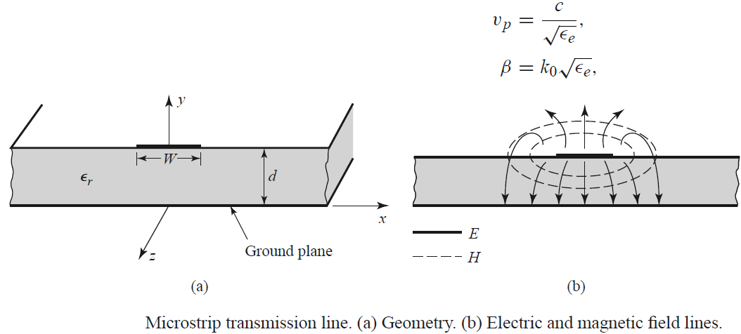

The effective dielectric constant of a microstrip line is given approximately by

 ---------------------------------------(6.1)

For a given characteristic impedance Z0 and dielectric constant εr, the W/d ratio can be

found as

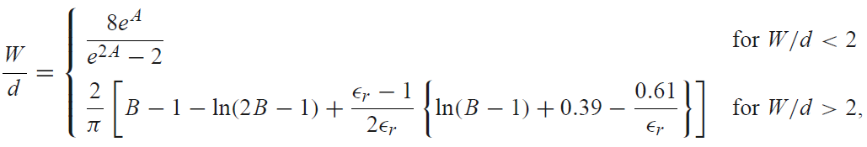----(6.2)

 ------------------------------------------(6.3)

The 180◦ hybrid junction is a four-port network with a 180◦ phase shift between the two output ports2 and 3. In the 180◦ hybrid junction shown in Fig 9.1, a signal applied to port 1 will be evenly split into two in-phase components at ports 2 and 3, and port 4 will be isolated. If the input is applied to port 4, it will be equally split into two components with a 180◦ phase difference at ports 2 and 3, and port 1 will be isolated. When operated as a combiner, with input signals applied at ports 2 and 3, the sum of the inputs will be formed at port 1, while the difference will be formed at port 4. Hence, ports 1 and 4 are referred to as the sum and difference ports, respectively. The scattering matrix for the ideal 3 dB 180 hybrid thus has the following form

|  |  |
| --- | --- |
| $$\left[S\right]=\frac{-j}{\sqrt{2}}\left[\begin{matrix}\begin{matrix}0 & 1 \\ 1 & 0\end{matrix} & \begin{matrix}1 & 0 \\ 0 & -1\end{matrix} \\ \begin{matrix} 1 & 0 \\ 0 & -1\end{matrix} & \begin{matrix}0 & 1 \\ 1 & 0\end{matrix}\end{matrix}\right]$$ |  |
| S-matrix of 180◦ phase shift Hybrid Ring junction |
|  | **Fig. 6.1 Hybrid Ring (rat race)** |

1. **PROCEDURE:**

Design and simulation of 50 Ω microstrip line using HFSS

The design and simulation flow for a 180-degree hybrid ring structure with Ansys HFSS software is as follows.

1. **Design of 50 Ω Microstrip line using HFSS**

Design of microstrip line parameters

The microstrip calculator determines the width and length of a microstrip line for a given characteristic impedance (Zo) and electrical length. The substrate parameters (εr and h) and the frequency of interest are required. After synthesize, the width (W) is calculated which will be used for hybrid ring design.

(SOURCE: https://www.emtalk.com/mscalc.php)

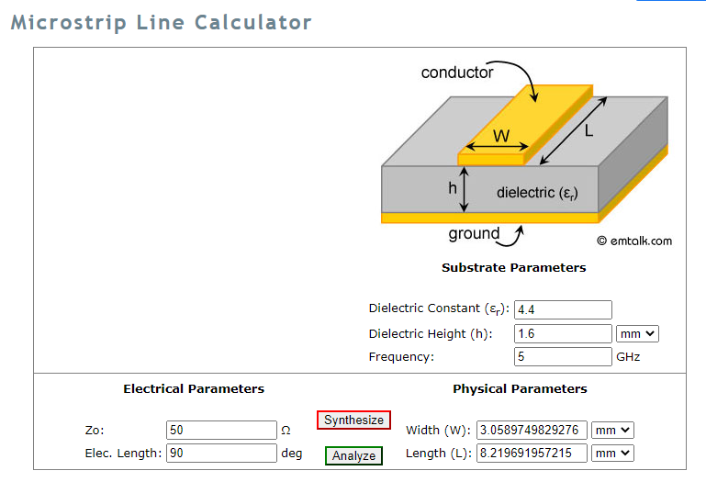

**Note: The detailed ANSYS Steps are given in supplementary soft copy in the lab.**

To analyze the results,

In project manager explorer

HFSS Design-->Analysis--> Right Click--> Add Solution Setup--> Advanced-->Solution Frequency 5 GHz--> Enter OK

Under Edit Sweep frequency

Distribution--> Linear Step--> 1 GHz (Start) 20 GHz (End), Step Size--> 0.1 GHz, Sweep Type--> FastClick on “Preview” to check the number of iterations execution

To run the program

HFSS--> Validate check (if error is displayed than check the boundary, dimensions and excitations)

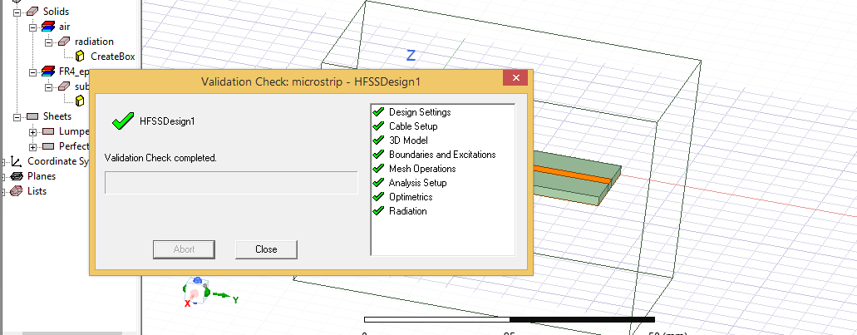

After validate--> Execute Analyze all

To see the result,

Choose the “Results” in Project Manager, (Right Click on Mouse)

Create Model Solution Data Report--> Rectangular port--> Choose S Parameter--> Quantity--> S(1,1), S(2,1), S(1,2), S(2,2)

Click on “New Report”

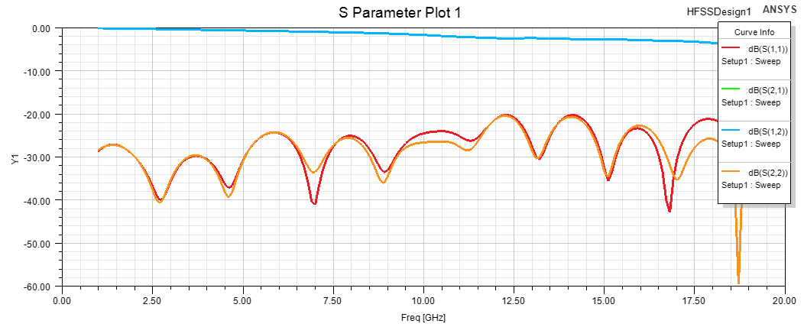

The results show that S11 & S22(Reflection coefficient) are less than –20 dB which suggest there is not much reflection on designed frequency. Hence microstrip line is typically can operate or can be used between 1 to 20 GHz.

The S12 or S21 (Transmission coefficient) is typically around 0 to –3dB which suggest the transmission is happens around 1 to 20 GHz. S12 or S21 gradually decreases with increase in the frequency which suggest the loss is gradually increases to higher frequency.

**HFSS Procedure for hybrid ring**



The average circumference of inner circle

$$C=\left(\frac{3λ}{4}\right)+3*\left(\frac{λ}{4}\right)=\frac{3λ}{2}=540° or 6π$$

Hence total electrical length of the circle is $l=\frac{3λ}{2}$. Here the characteristic impedance of the ring transmission line is $\sqrt{2}Z_{0}$. For other ports, the characteristics impedance is Z0. The width of the $\sqrt{2}Z_{0}(=70.71Ω)$ inner ring and width of the Z0 ports are selected by microstrip calculator.

**Design of microstrip line parameters**

The microstrip calculator determines the width and length of a microstrip line for a given characteristic impedance (Zo) and electrical length. The substrate parameters (εr and h) and the frequency of interest are required.

(SOURCE: https://www.emtalk.com/mscalc.php)

**For port-line width,**

For e.g., Operating frequency f= 2.4GHz, Dielectric Constant (εr) = 4.4, Dielectric Height = 1.6 mm, Z0= 50 Ω and Electrical length= 90 deg(Can be any value since an electrical length is not fixed for the port) 🡪 Synthesize.

Calculated port width = 3 mm

**For inner radius width,**

For e.g., Operating frequency f= 2.4GHz, Dielectric Constant (εr) = 4.4, Dielectric Height = 1.6 mm, Z0= 70.7 Ω and Electrical length= 540 deg (Since electrical length of the circle is ) 🡪 Synthesize.

Calculated radius width =1.62 mm

Length = 105 mm

**Design Parameters**

|  |  |
| --- | --- |
| A | Width (70.7 Ω) = 1.62 mm |
| Length (70.7 Ω) = 105 mm |
| Radius of the circle (A)= C/2π (Since C= 2πr)  =105/2π = 16.71 mm |
| Radius of inner circle= 16.71 – (1.62/2) =15.9 mm |
| Radius of outer circle= 16.71 + (1.62/2) = 17.52 mm |

1. **The hybrid ring design using microstrip line in HFSS**

**(The detailed design in supplementary soft copy in the lab)**

**Analysis setup & Results**

1. In project manager,
2. Analysis🡪Right Mouse Click🡪 Add Solution Setup🡪 Advanced🡪 Solution Frequency🡪 2.4 GHz🡪 Enter OK
3. Sweep Type🡪 Interpolating🡪 Start🡪 1GHz🡪 End🡪 5GHz, Points🡪 100
4. HFSS🡪 Design setting🡪 Material Override🡪 Checked
5. After validate--> Execute Analyze all
6. To see the result,
   1. Choose the “Results” in Project Manager, (Right Click on Mouse)
7. Create Model Solution Data Report--> Rectangular port--> Choose S Parameter--> Quantity--> S(1,1), S(2,1), S(1,2), S(2,2)
8. Click on “New Report”

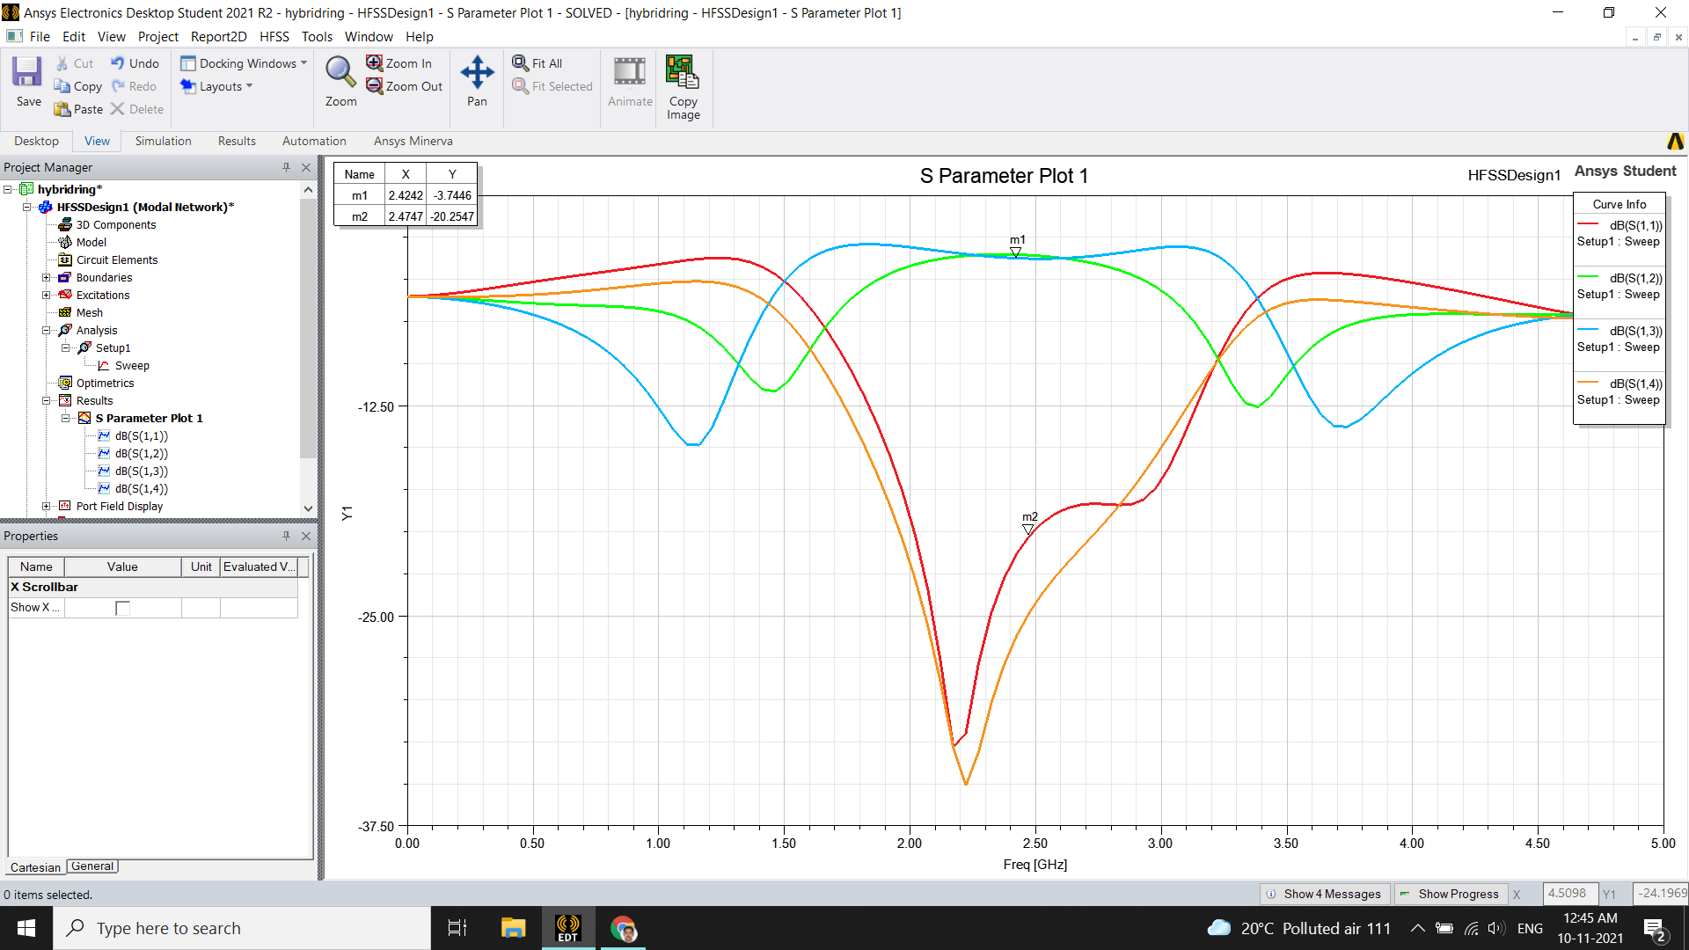

1. If you are getting warning message as “Adaptive Passes did not converge based on specified criteria”
2. Go to analysis setup in project manager and increase the Maximum number passes from 6.
3. [S] matrix of hybrid can be found in HFSS🡪 Results🡪 Solution Data🡪 Freq🡪 Operating Frequency (Here 2.4 GHz)

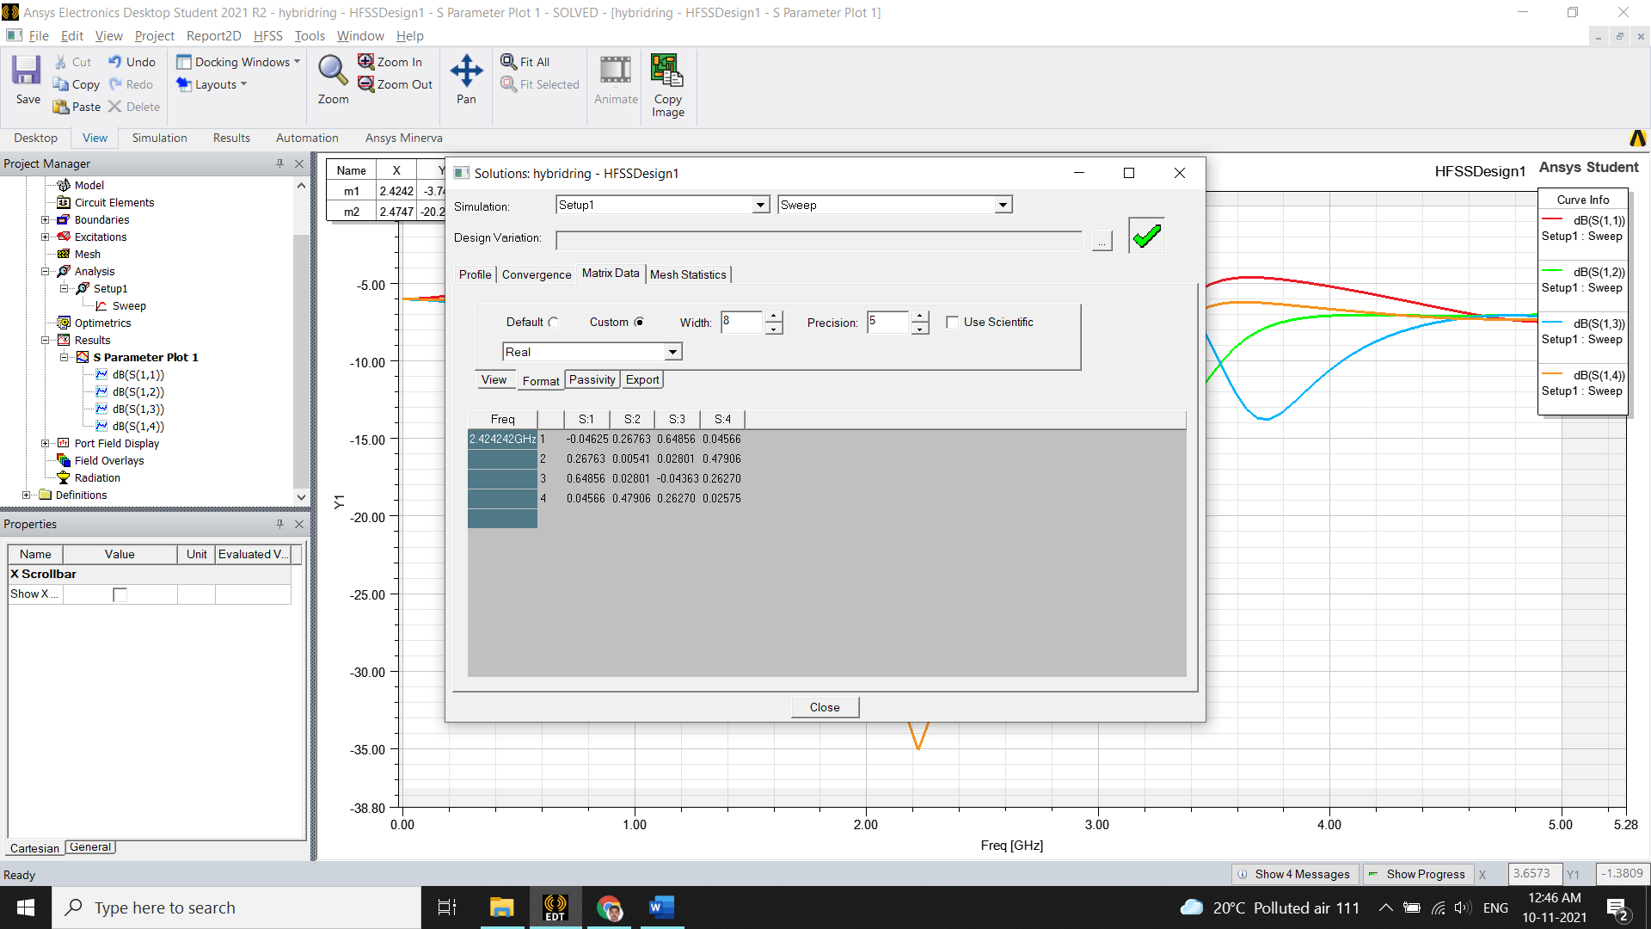

1. To view electric field propagation inside the ring
2. View🡪 Select by Name🡪 Select ring & Rectangle2 (Using Ctrl Key)🡪 Enter OK🡪 Right Mouse Click🡪 Plot Fields🡪 E🡪 Mag_E🡪 Enter Done
3. In project Explorer🡪 Field Overlay🡪 E Field 🡪 Mag_E1🡪 Right Mouse Click 🡪 Animate🡪 Enter OK

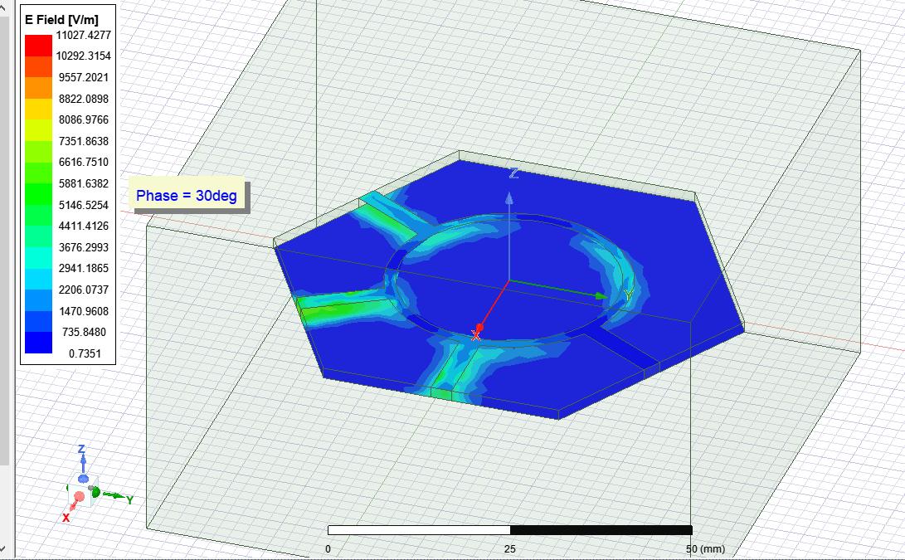

The excitation source can be edited to give two input sources in port 2 and 3. The sum of the port will be appear in the port 1 and difference appear in port 4

1. In project manager,
   1. Excitation🡪Edit source. On the source table
   2. Source 2:1, Magnitude=1 W, Phase 0 deg
   3. Source 3:1, Magnitude=1 W, Phase 0 deg
   4. Enter Ok and animate (Repeat the Step 14)
   5. Now user can observe the sum and difference of input source. Try also source 2:1, Magnitude=1 W, Phase 0 deg and Source 3:1, Magnitude=1 W, Phase 180 deg

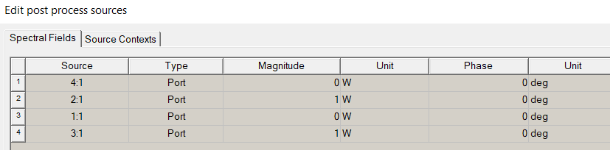

1. **RESULTS/OUTCOMES**

Construct a table of S-parameters for microstrip line and plot s-parameter matrix

|  |  |
| --- | --- |
| **PARAMETERS** | **(dB)** |
| **S11** |  |
| **S12** |  |
| **S21** |  |
| **S22** |  |

Write S matrix in dB for simulated hybrid ring and plot the S-parameters $\left[S\right]=\frac{-j}{\sqrt{2}}\left[\begin{matrix}\begin{matrix}0 & 1 \\ 1 & 0\end{matrix} & \begin{matrix}1 & 0 \\ 0 & -1\end{matrix} \\ \begin{matrix} 1 & 0 \\ 0 & -1\end{matrix} & \begin{matrix}0 & 1 \\ 1 & 0\end{matrix}\end{matrix}\right]$

**Observations**

|  |  |  |  |
| --- | --- | --- | --- |
| **Sl.No** | **Criteria** | Max Marks | Marks obtained |
| **Data sheet** | | | |
| 1 | Problem statement | 10 |  |
| 2 | Design & specifications | 10 |  |
| 3 | Expected output | 10 |  |
| **Record** | | | |
| 4 | Simulation/ Conduction of the experiment | 15 |  |
| 5 | Analysis of the result | 15 |  |
| 6 | Viva | 40 |  |
| 7 | Total | 100 |  |
| **Scale down to 10 marks** | | | |

**EXPERIMENT 7**

**Design and** **Simulation of Rectangular Waveguide and** **Magic-Tee using HFSS**

**Topic Learning Objectives:**

The student must be able to:

1. Design and simulation of a WR-90 Rectangle waveguide and plotting & analysis of propagation constant, VSWR and S-Parameters
2. Design and Create a Magic Tee structure at a given operating frequency using HFSS Design environment
3. Simulate and analyze the S parameters of Magic Tee
4. **AIM:** To design, simulate and analyze the S parameters of Magic Tee at a given frequency band
5. **EQUIPMENT REQUIRED:** 64 bit Personal computer/Laptop and HFSS
6. **THEORY:**

**Rectangular Waveguide:**

Rectangular waveguides were one of the earliest types of transmission lines used to transport

microwave signals, and they are still used for many applications. A large variety of components

such as couplers, detectors, isolators, attenuators, and slotted lines are commercially available

for various standard waveguide bands from 1 to 220 GHz. The high-power systems, millimeter wave applications, satellite systems, and some precision test applications are need rectangular waveguides. The hollow rectangular waveguide can propagate TM and TE modes but not TEM

waves since only one conductor is present.



Fig 7.1 Geometry of a rectangular waveguide

The transverse field components of the TEmn mode can be written as

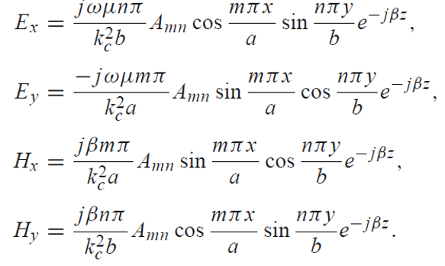 (7.1 a -d)

The propagation constant is ( 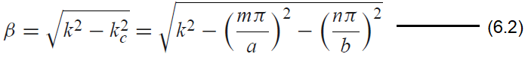7.2)

Each mode (each combination of m and n) has a cutoff frequency fcmn given by

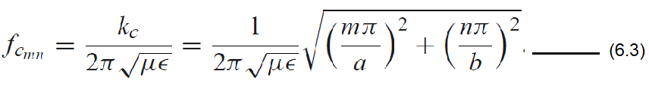 (7.3)

The lowest cutoff frequency occurs for the TE10 (m = 1, n = 0) mode:

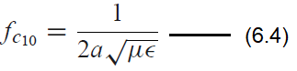 (7.4)

**Magic Tee**

A combination of E-plane and H-plane tees form a hybrid Tee (Magic tee) having four ports is shown in Fig 5.1. Magic tee has the following characteristics: If two in-phase waves of equal magnitude are fed into ports 1 & 2, the output at port 3 is subtracted so the output is zero. The total output power additively appears at port 4. Hence port3 is called difference or E-plane arm and port 4 is called sum arm or H-arm. A wave incident at port 4 divides equally in phase between ports 1 and 2. A wave incident at port 3 divides equally with out of phase difference between ports 1 and 2. Thus the S-parameters of a magic tee are expressed as:

${s_{13}=s_{31}=\frac{1}{\sqrt{2}} {=-s}_{23}=-s_{32} and s}_{34}=s_{43}=0$ (7.5)

${s_{14}=s_{41}=\frac{1}{\sqrt{2}} {=s}_{24}=s_{42} and s}_{34}=s_{43}=0$ (7.6)

A wave incident to port 1 or port 2 will not appear in the other port

0. (7.7)

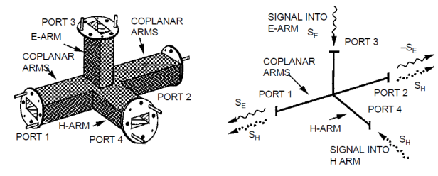  
Thus the S- matrix is of magic tee is

$\left[S\right]=\frac{1}{\sqrt{2}}\left[\begin{matrix}\begin{matrix}0 & 0 \\ 0 & 0\end{matrix} & \begin{matrix}1 & 1 \\ -1 & 1\end{matrix} \\ \begin{matrix} 1 & -1 \\ 1 & 1\end{matrix} & \begin{matrix}0 & 0 \\ 0 & 0\end{matrix}\end{matrix}\right]$

**PROCEDURE:** The design and simulation flow for a rectangular waveguide and Magic-Tee structure with Ansys HFSS software is as follows. **Note: The detailed ANSYS Steps are given in supplementary soft copy in the lab.**

**Fig 7.2: Magic Tee**

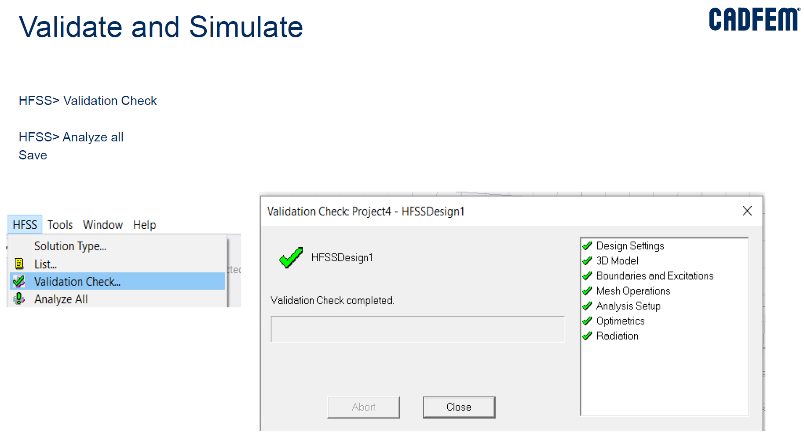

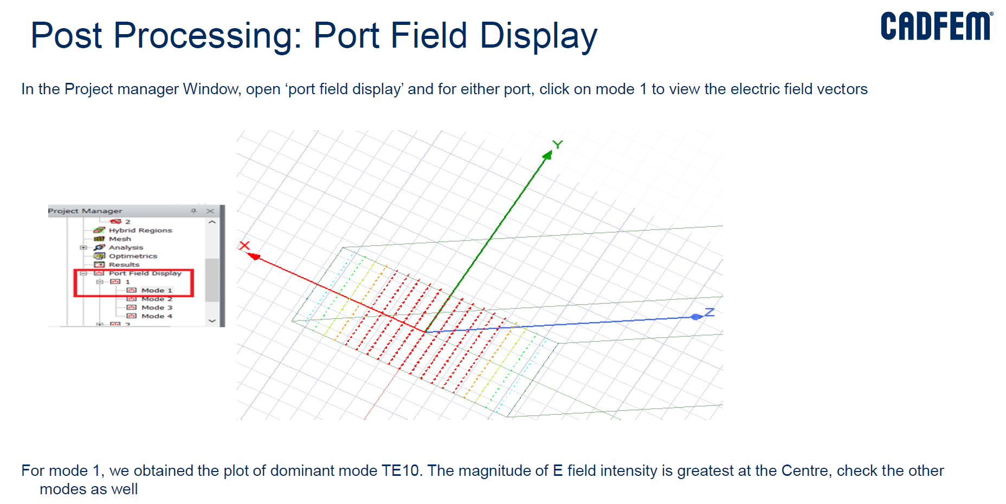

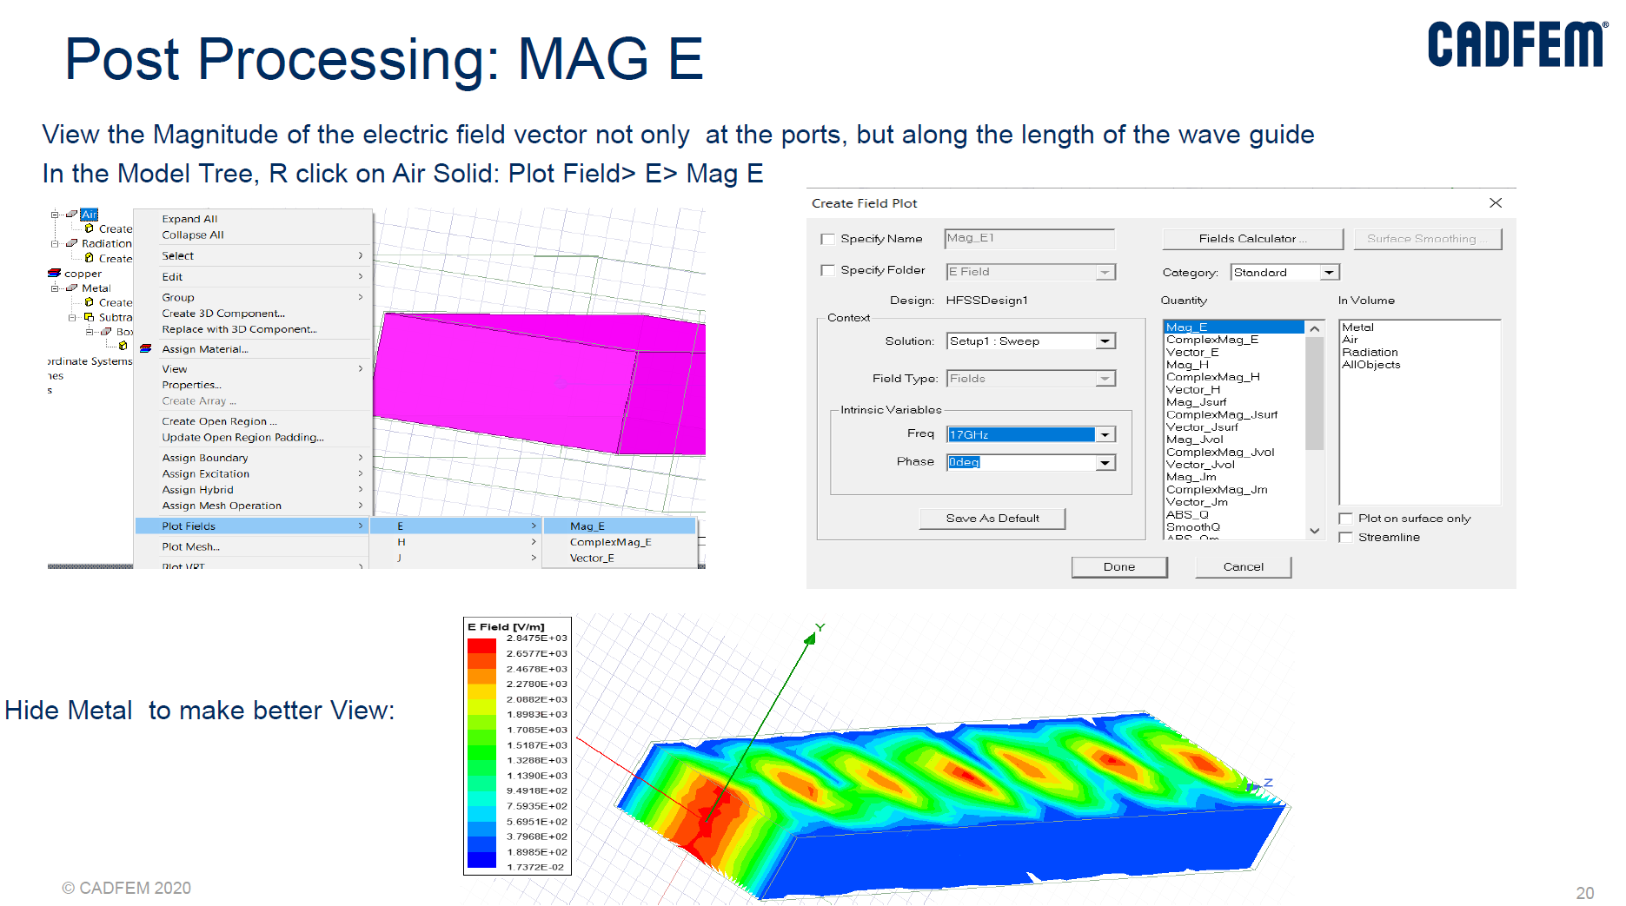

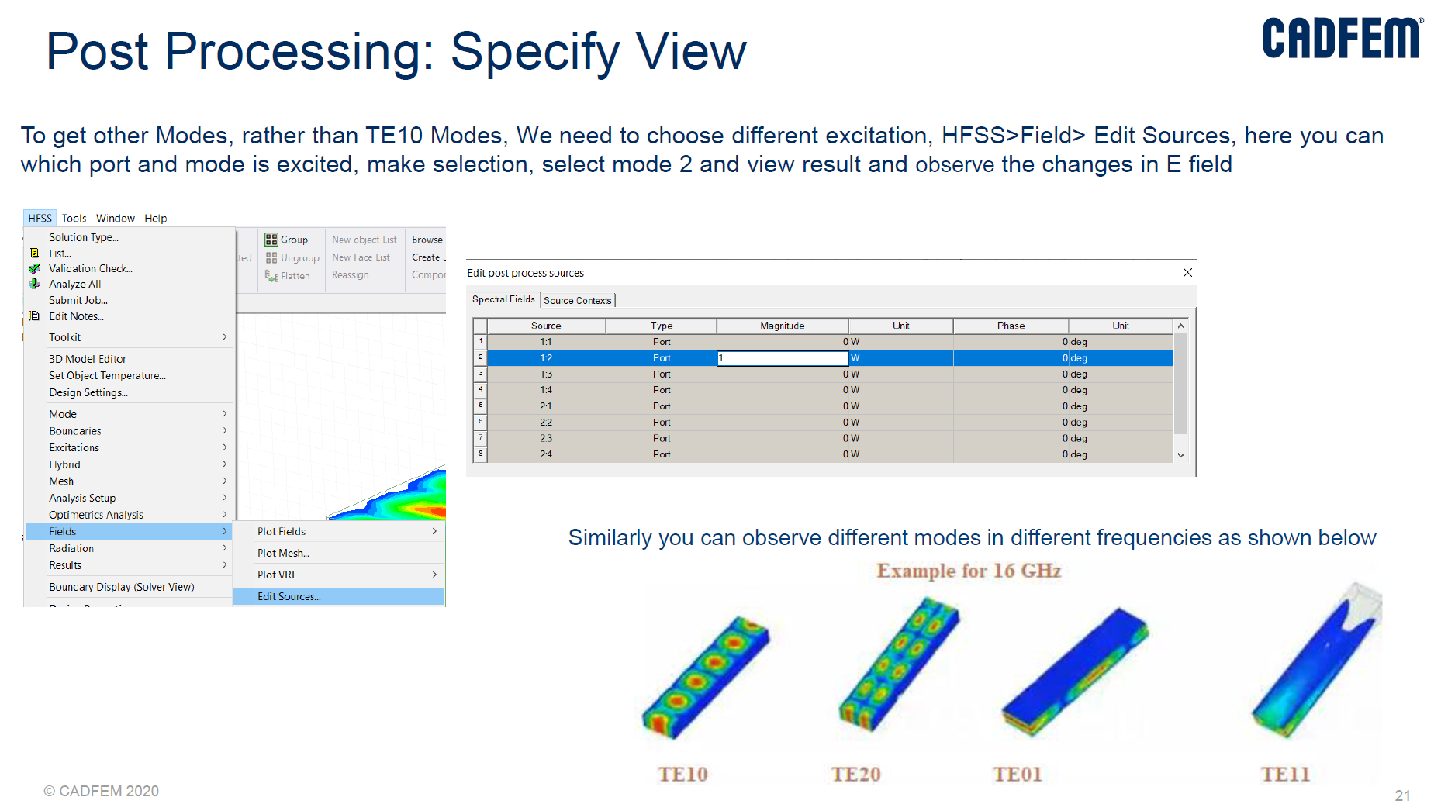

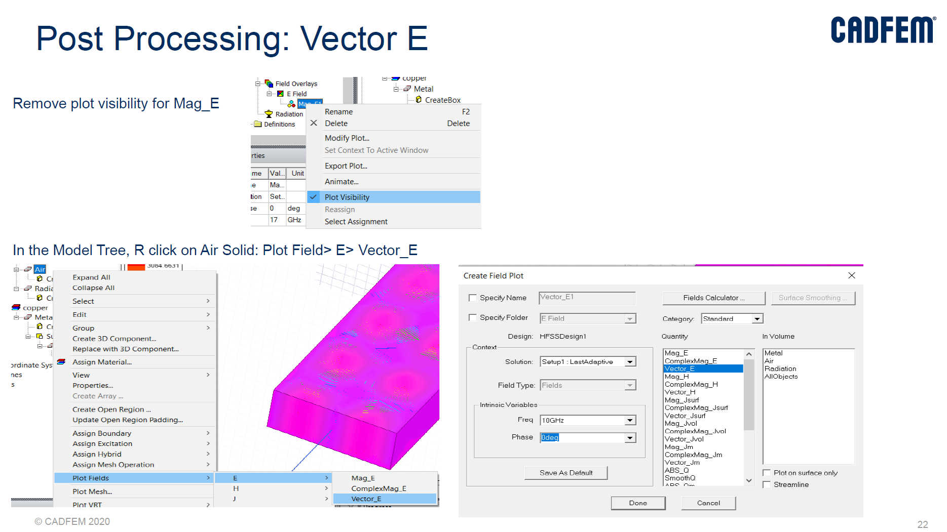

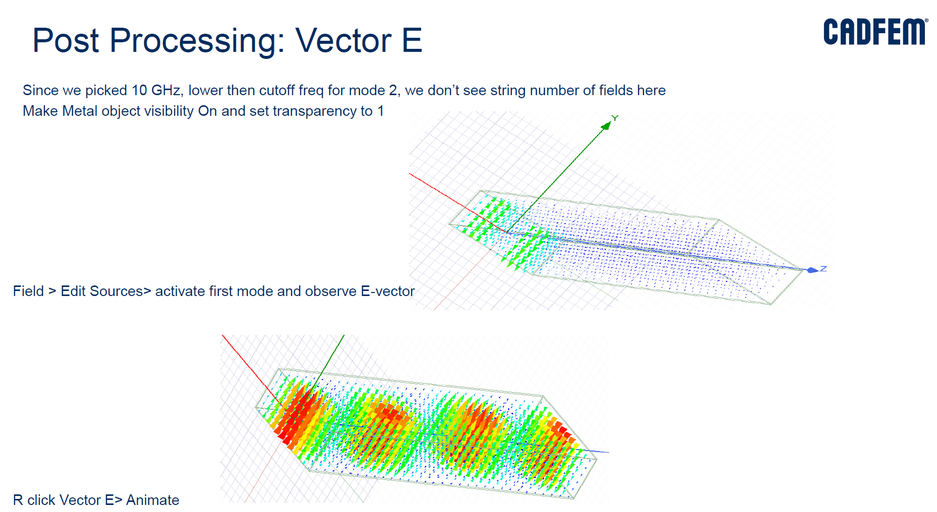

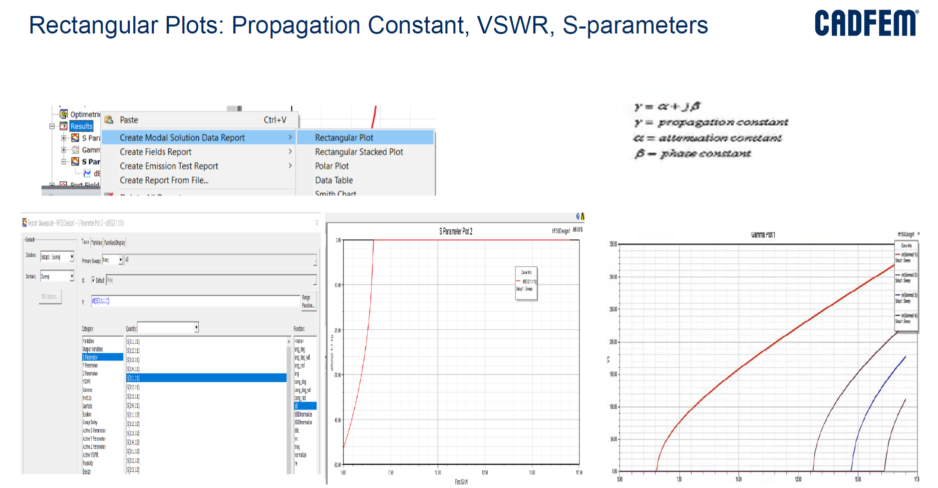

**Magic Tee HFSS Procedure**

**Note: The detailed ANSYS Steps are given in supplementary soft copy in the lab.**

1. Analysis Setup

In project manager

Analysis🡪Add Solution Setu🡪 Solution frequency🡪10GHz🡪 Enter OK

Add Frequency Sweep🡪 Sweep type🡪 Interpolation🡪Type🡪 LinearStep

Start🡪 6 GHz, Stop 🡪 15 GHz, Step Size🡪0.1 GHz🡪 Enter OK

1. To run the program

HFSS--> Validate check (if error is displayed than check the boundary, dimensions and excitations)

After validate--> Execute Analyze all

*(****Note:*** *if project to be saved than use a relevant name and designated folder to save the project. Please check with the technical lab staff to know right location. Data loss may occur if the location has been chosen wrongly.)*

1. To see the result,

Choose the “Results” in Project Manager, (Right Click on Mouse)

Create Model Solution Data Report--> Rectangular port--> Choose S Parameter--> Quantity--> S(1,1), S(2,1), S(1,2), S(2,2)

Click on “New Report”

To view fields and animation

Mouse click on any arms of magic tee🡪Create Field overlay🡪 Plot field🡪E🡪 Vector_E

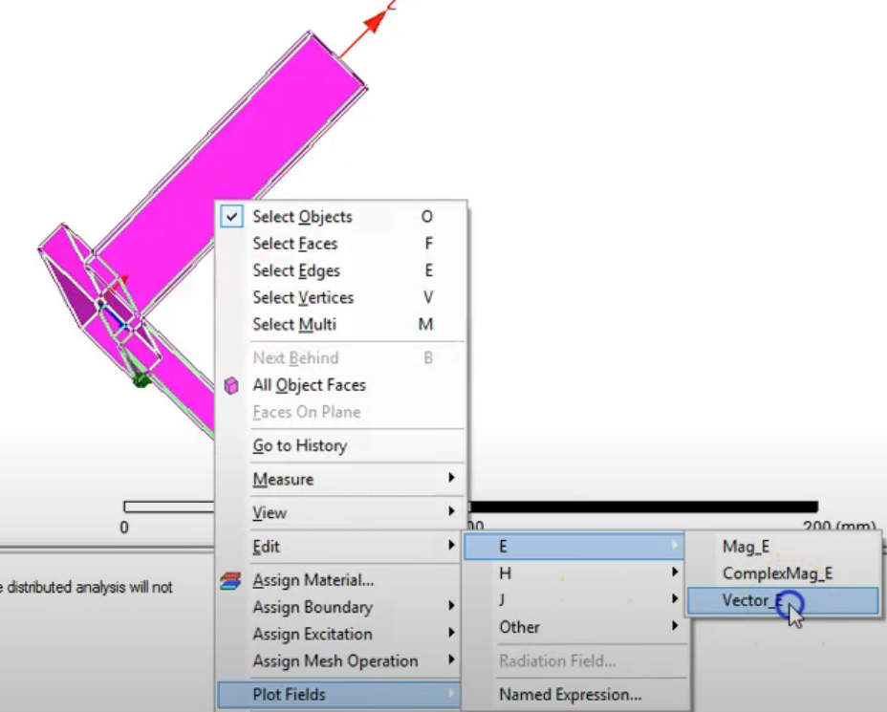

On Create Field Plot Window, Enter Done.

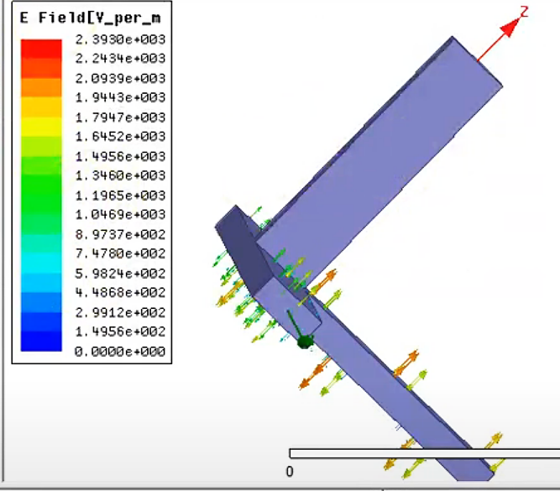

To animate field🡪 In project manager🡪 Field Overlays🡪E Field🡪Vector_E🡪Animate🡪On Setup Animate🡪 Enter OK

Similarly E-field magnitude(Mag_E) plot can be seen

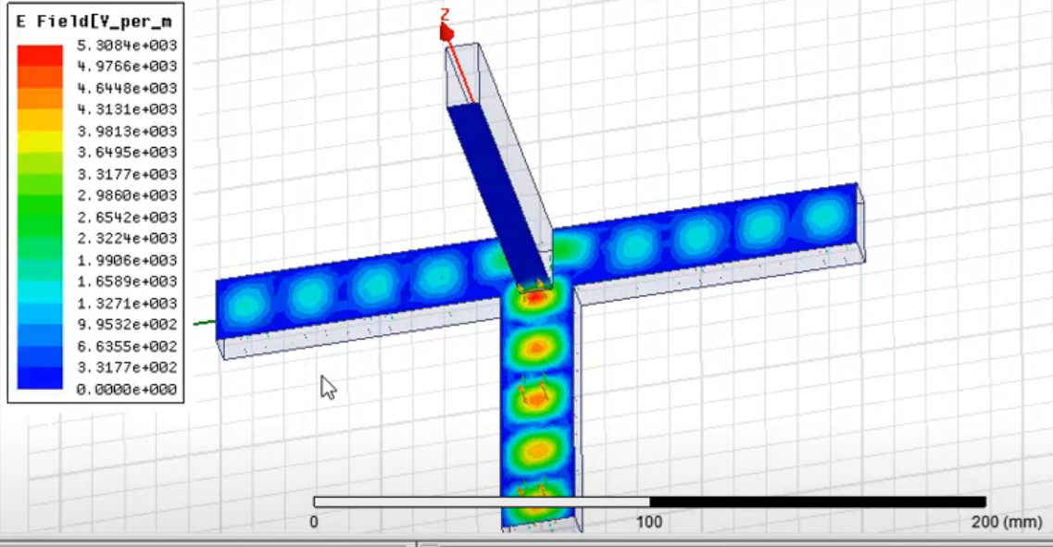

1. **RESULTS/OUTCOMES**

**Rectangular Waveguide**

S-parameter plot and Propagation constant plot vs Frequency

**Magic Tee**

Construct a table of S-parameters

|  |  |
| --- | --- |
| **PARAMETERS** | **(dB)** |
| S11 |  |
| S22 |  |
| S33 |  |
| S44 |  |
| S12=S21 |  |
| S13=S31 |  |
| S14=S41 |  |
| S23=S32 |  |
| S24=S42 |  |
| S34=S43 |  |

**Observations:**

|  |  |  |  |
| --- | --- | --- | --- |
| **Sl.No** | **Criteria** | **Max Marks** | **Marks obtained** |
| **Data sheet** | | | |
| 1 | Problem statement | 10 |  |
| 2 | Design & specifications | 10 |  |
| 3 | Expected output | 10 |  |
| **Record** | | | |
| 4 | Simulation/ Conduction of the experiment | 15 |  |
| 5 | Analysis of the result | 15 |  |
| 6 | Viva | 40 |  |
| 7 | Total | 100 |  |
| **Scale down to 10 marks** | | | |

**EXPERIMENT 8**

**Design and Simulation of Patch Antenna and Optimetrics using HFSS**

**Topic Learning Objectives:**

The student must be able to:

1. Design the rectangular microstrip patch antenna, dipole at given operating frequency.
2. Simulate the antennas with HFSS software.
3. Analyze the S parameters and optimetrics of the antennas.
4. **AIM:** Design and simulation of a coaxial fed rectangular microstrip patch, printed dipole and horn antennas at a specified resonant frequency with HFSS software.
5. **EQUIPMENT REQUIRED:** 64 bit Personal computer/Laptop and Ansys HFSS design Kit
6. **THEORY:**

**Microstrip patch antenna**

Thedesign parameters of Rectangular microstrip patch antenna are: frequency of operation (f), dielectric constant of the substrate (εr) and height of dielectric substrate (h). The substrate parameters considered are: εr = 2.2(RT Duroid), *h* = 1.57 mm. Using the above specifications, the rectangular patch is designed as follows:

For efficient radiation, the width $w$

|  |  |
| --- | --- |
| $$w=\frac{c}{2f}\sqrt{\frac{2}{ϵ_{r}+1}}$$ | (8.1) |

Where, $c$ is velocity of light, $f$ = resonant frequency in GHz, $ε_{r}$ =Dielectric constant of the substrate.

The effective length $L_{eff}$ is given as

|  |  |
| --- | --- |
| $$L_{eff}=L+2δL$$ | (8.2) |

Where $δL$ is

|  |  |
| --- | --- |
| $$δL=0.412h\left(\frac{ϵ_{r}+0.3}{ϵ_{r}-0.258}\right)\left(\frac{\frac{w}{h}+0.264}{\frac{w}{h}+0.8}\right)$$ | (8.3) |

The effective dielectric constant is given by,

|  |  |
| --- | --- |
| ${{ ε}_{reff}=\frac{ε_{r}+1}{2}+\frac{ε_{r}-1}{2}\left[1+12\frac{h}{W}\right]}^{-1/2}$ | (8.4) |

The effective length of the patch $L_{eff}$ is

|  |  |
| --- | --- |
| $$L_{eff}=\frac{c}{2f\sqrt{ε_{reff}} }$$ | (8.5) |

The normalized radiation pattern in E-plane and H-plane is given by:

|  |  |
| --- | --- |
| $$E_{θ}=\frac{Sin\left(\frac{kwSinθSinφ}{2}\right)}{\frac{kwSinθSinφ}{2}}\operatorname{Cos}{\begin{aligned}\left(\frac{kL}{2}sinθcosφ\right)Cosφ \end{aligned}}$$ | (8.6) |
| $$E_{φ}=-\frac{\operatorname{Sin}\left(\frac{kwSinθSinφ}{2}\right)}{\left(\frac{kwSinθSinφ}{2}\right)}\operatorname{Cos}{\begin{aligned}\left(\frac{kL}{2}sinθcosφ\right)CosθSinφ\end{aligned}}$$ | (8.7) |

**Dipole antenna:**

Thedesign parameters of planar dipole antenna are same as that of a microstrip patch antenna.

Dipole length is $L= \frac{λ}{2}$.

The normalized radiation pattern in E-plane and H-plane is respectively given by

|  |  |
| --- | --- |
| $$E_{θ}=η\frac{sin\left(\frac{π}{2}cosθ\right)}{sinθ}$$ | (8.8) |
| $$H_{θ}=\frac{sin\left(\frac{π}{2}cosθ\right)}{sinθ}$$ | (8.9) |

Where $η=120π$.

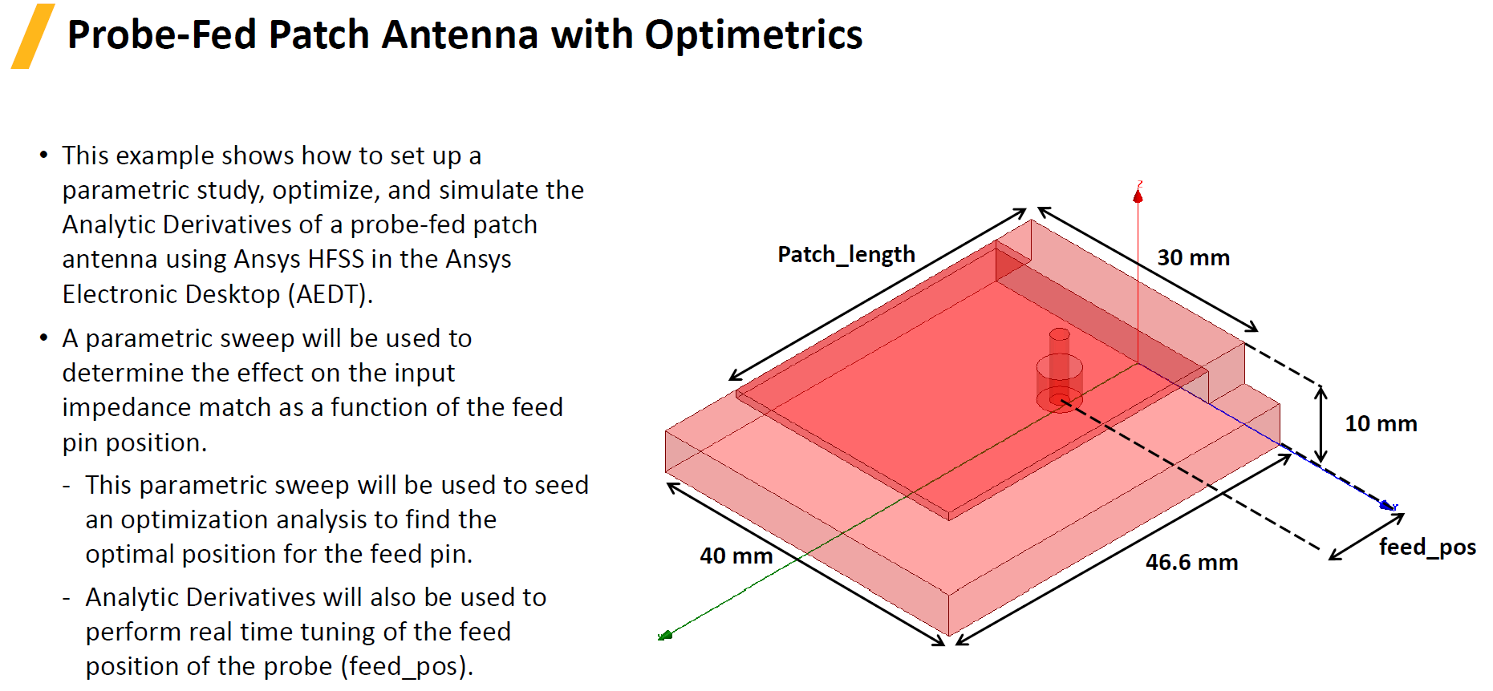

**Note: The detailed ANSYS Steps are given in supplementary soft copy in the lab.**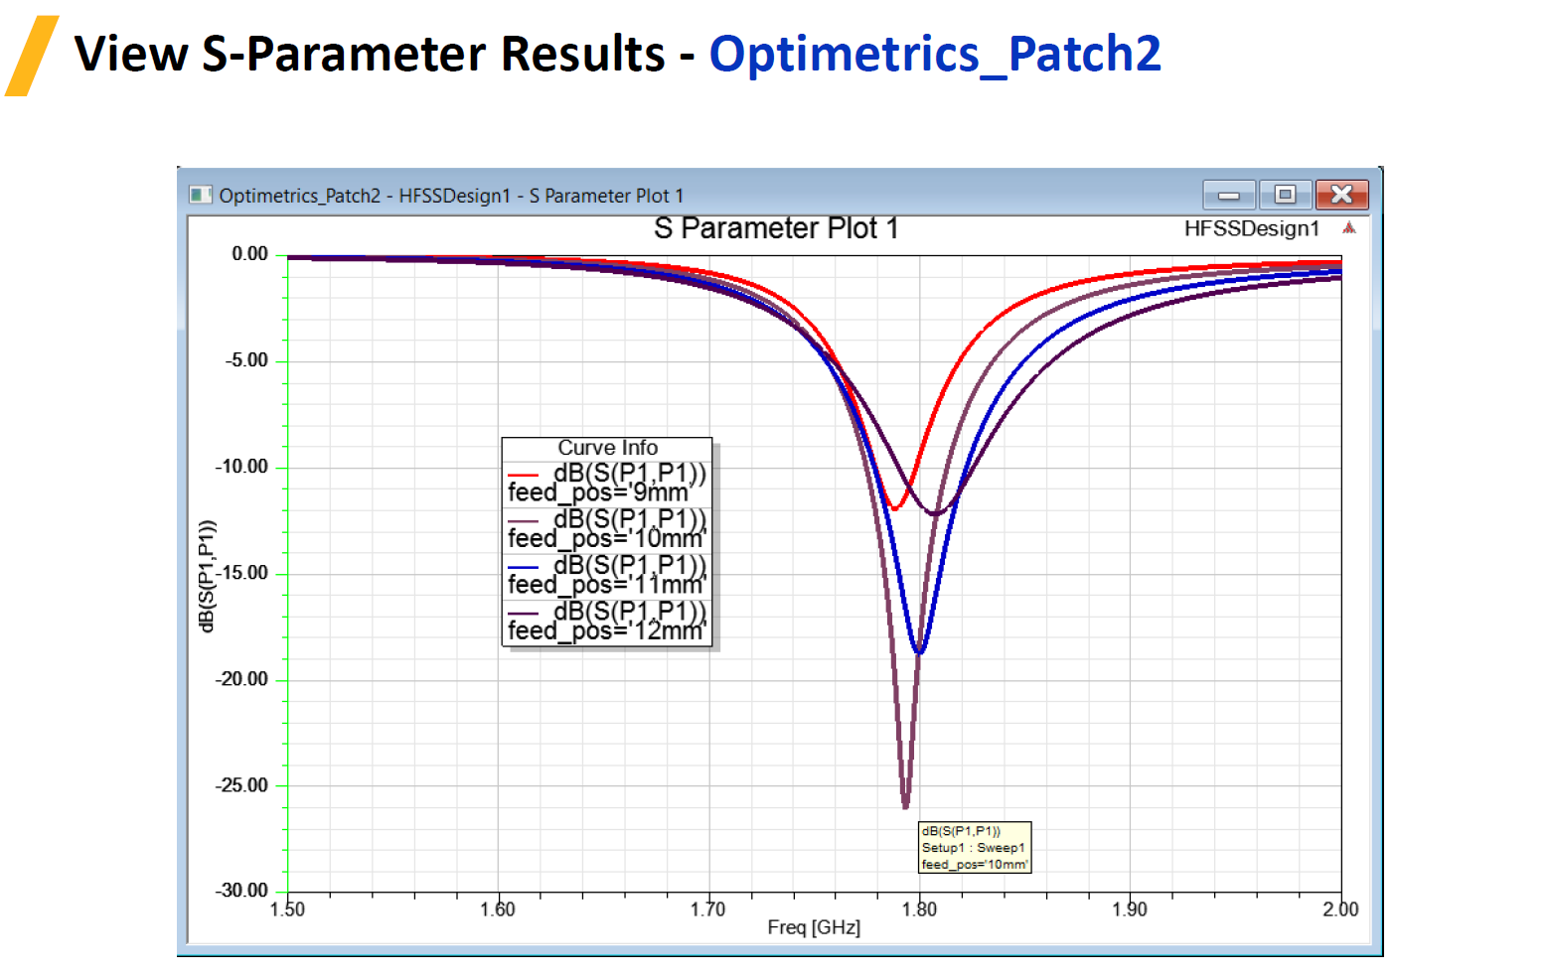

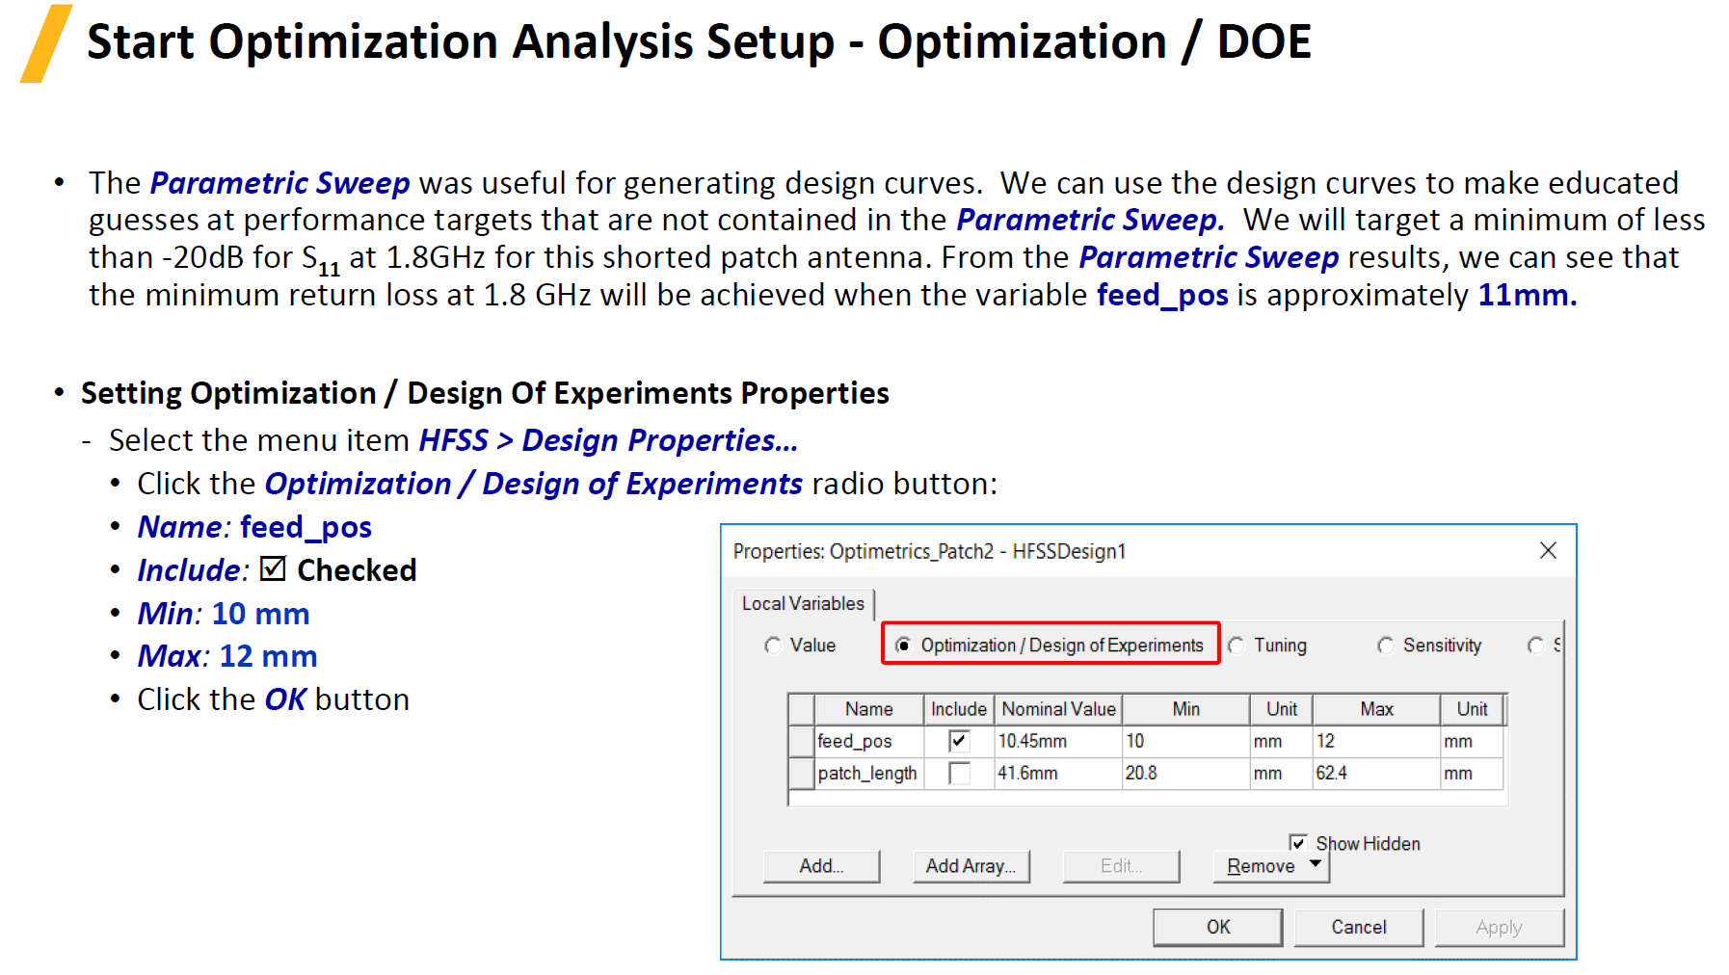



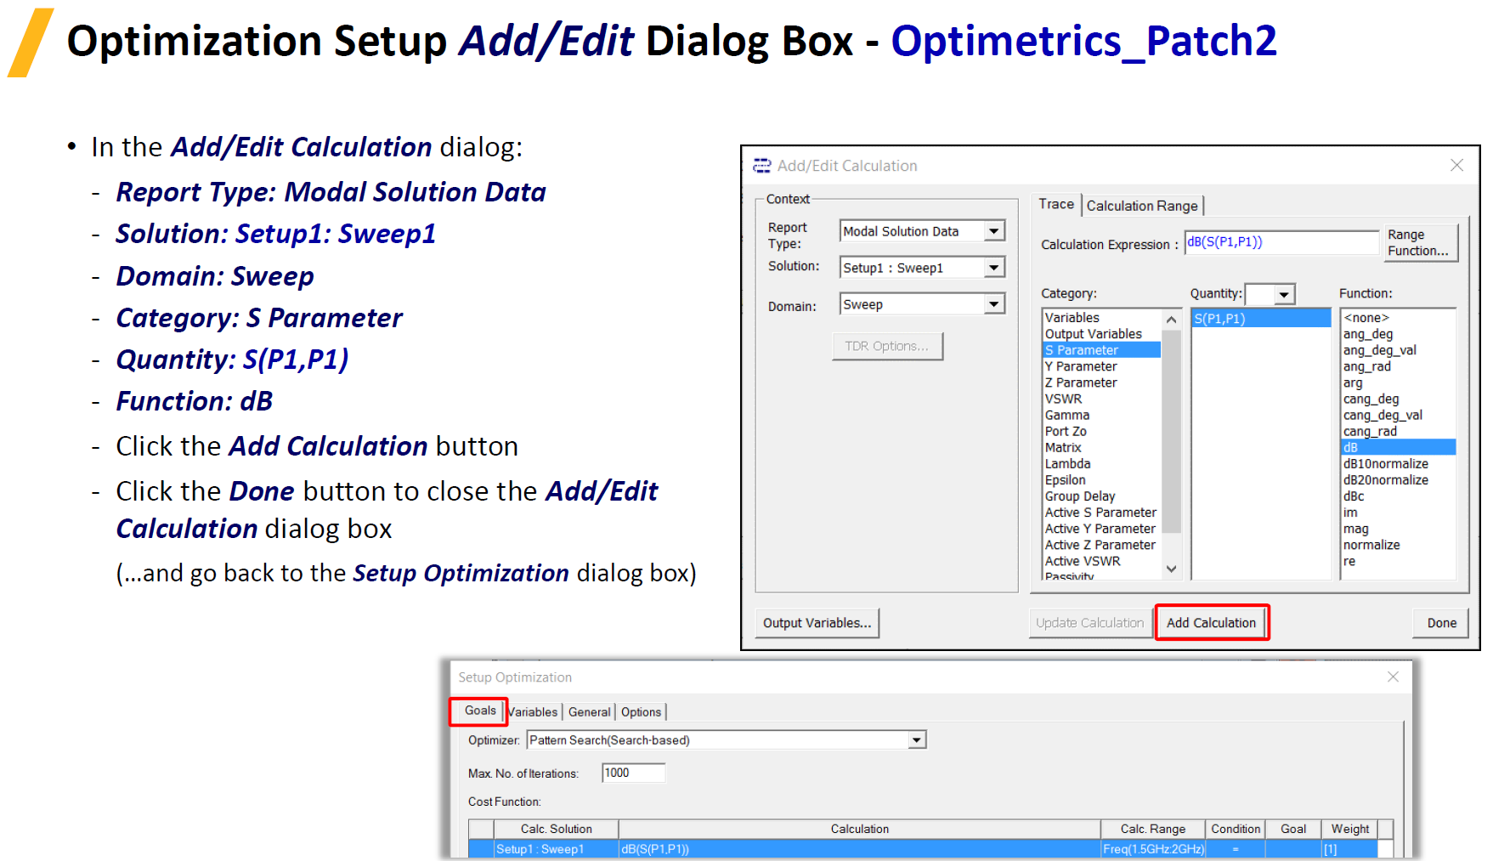

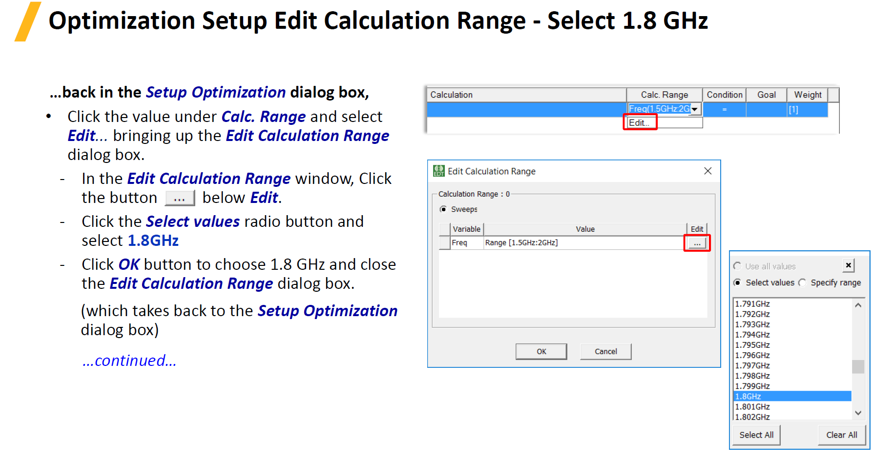

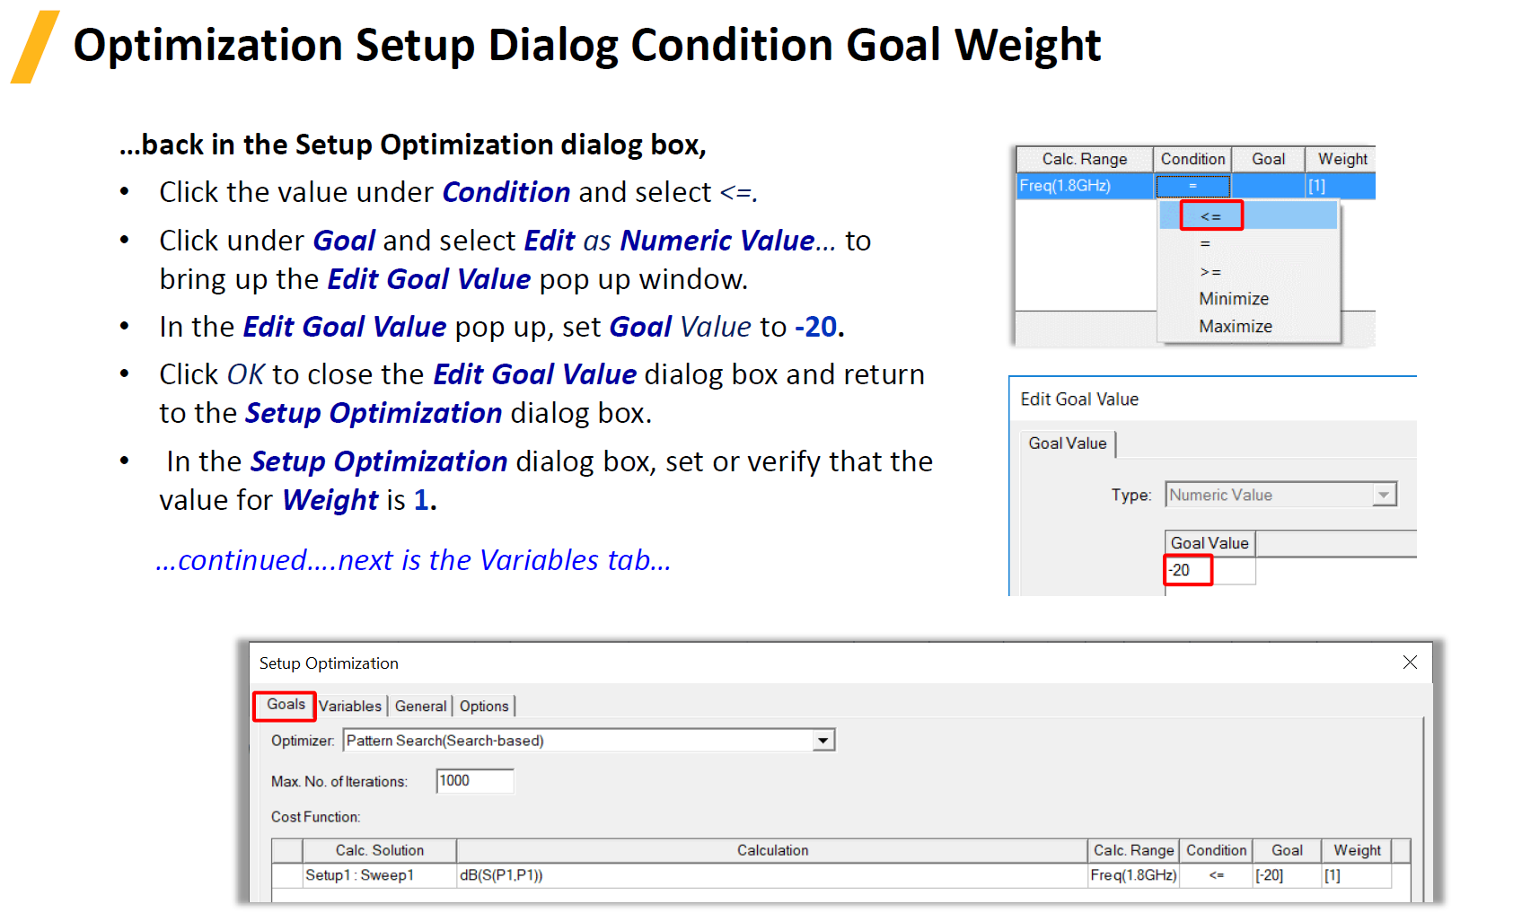

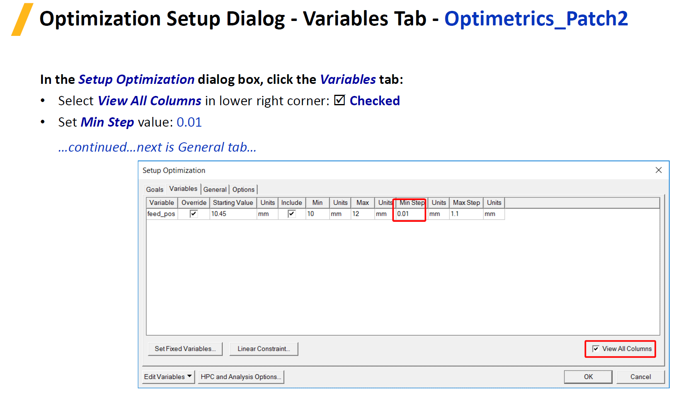

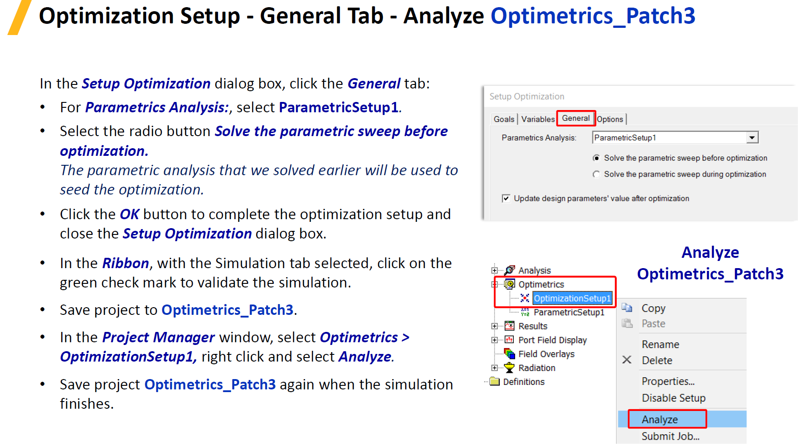

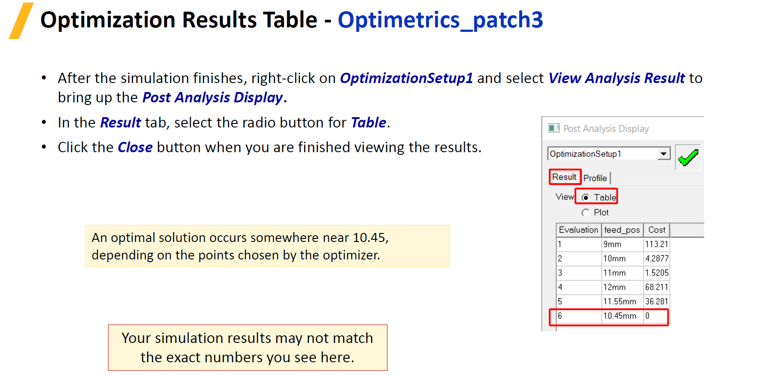

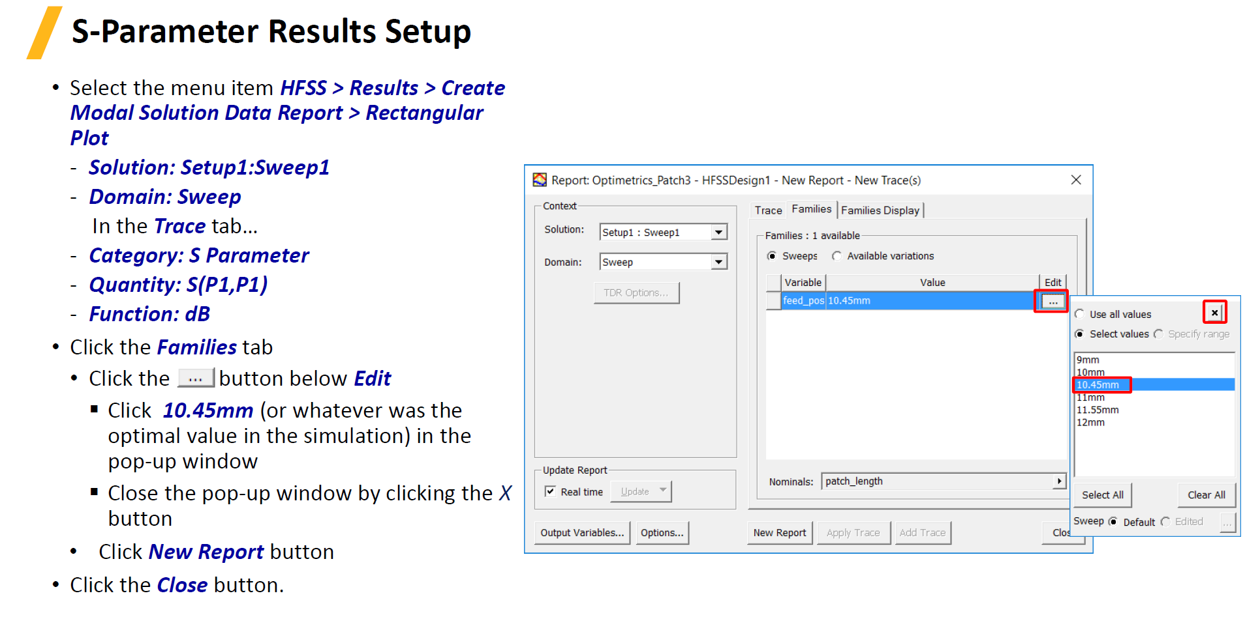

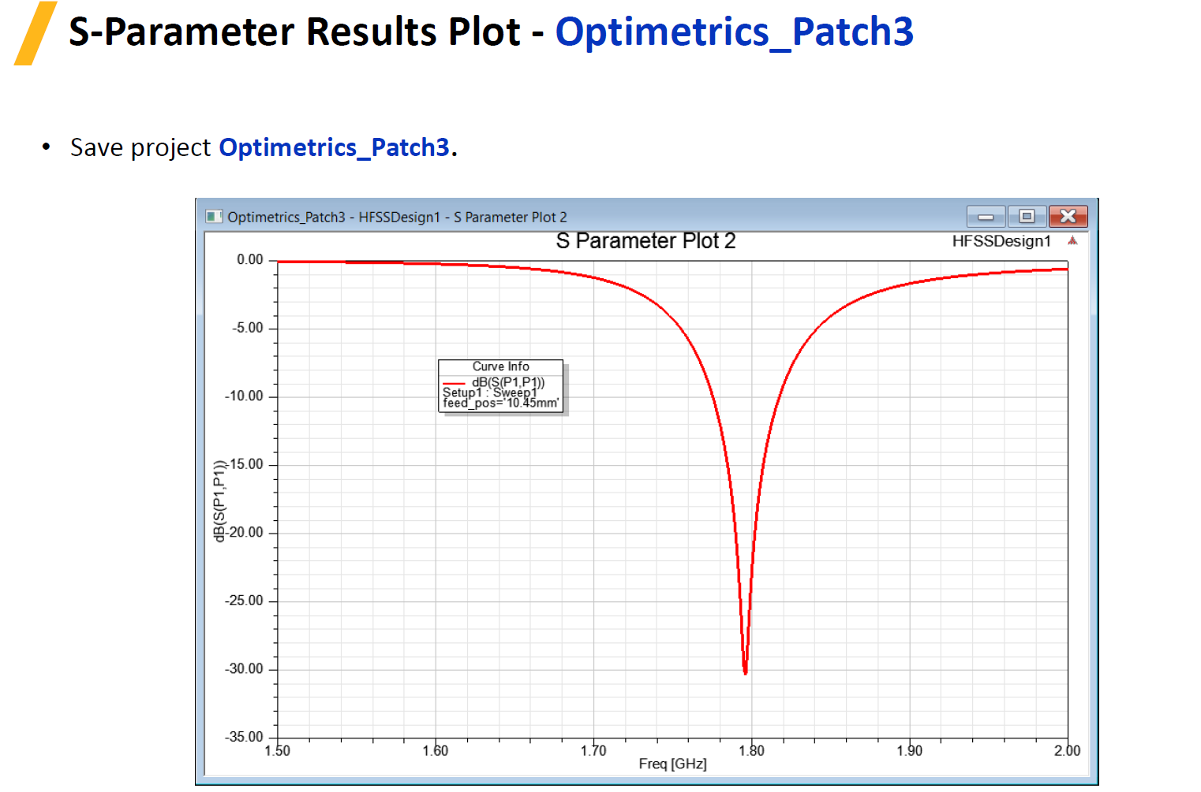

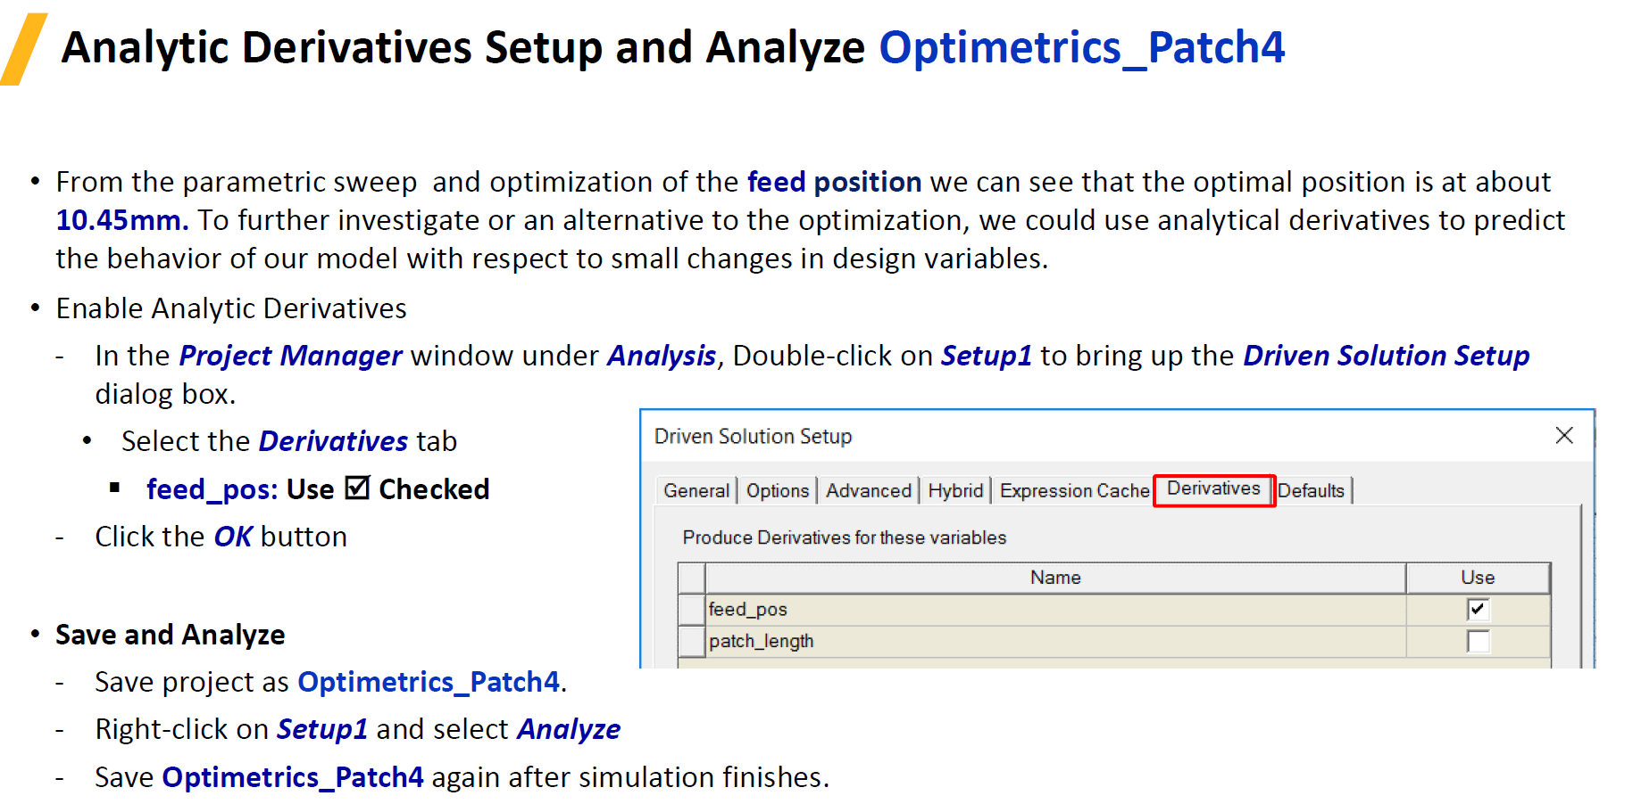

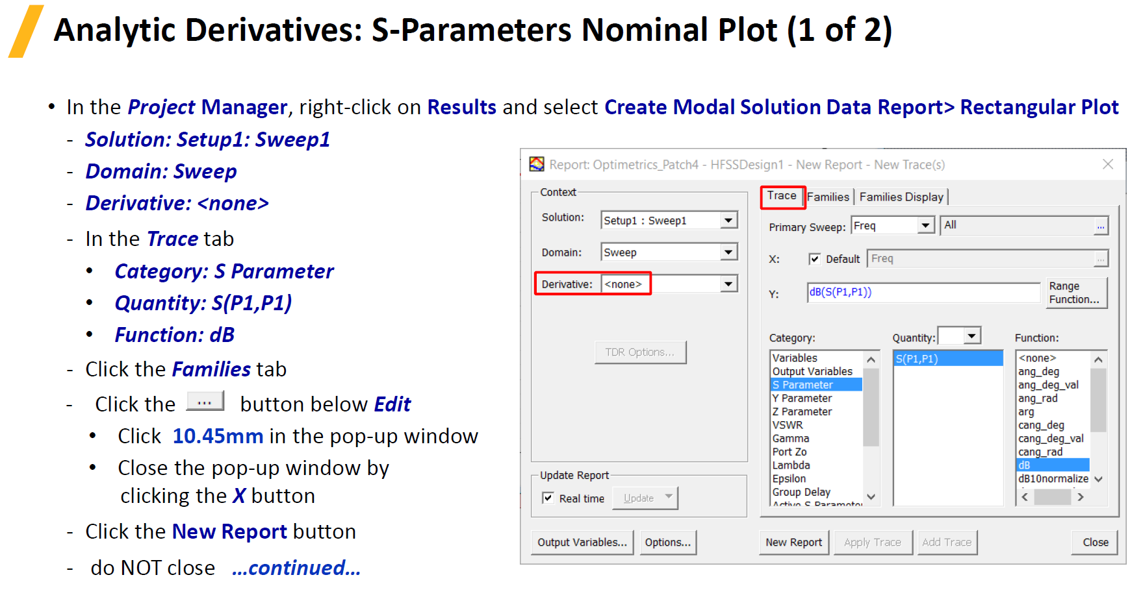

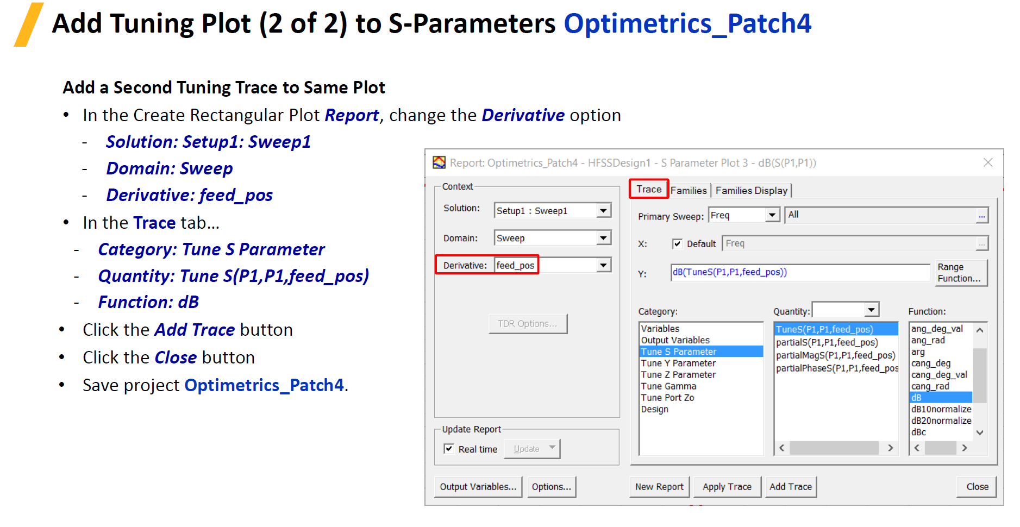

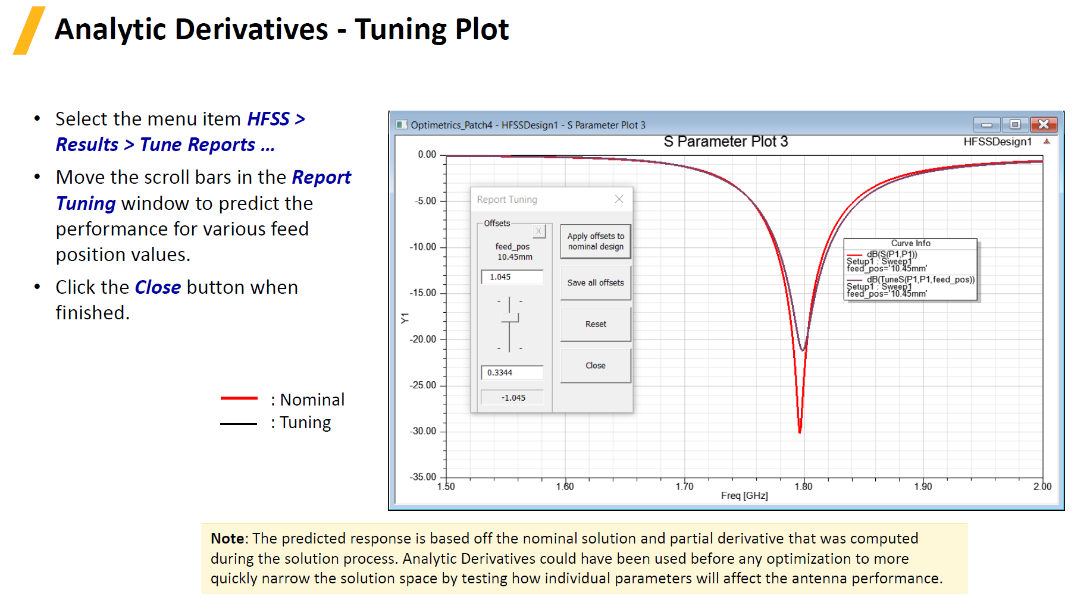

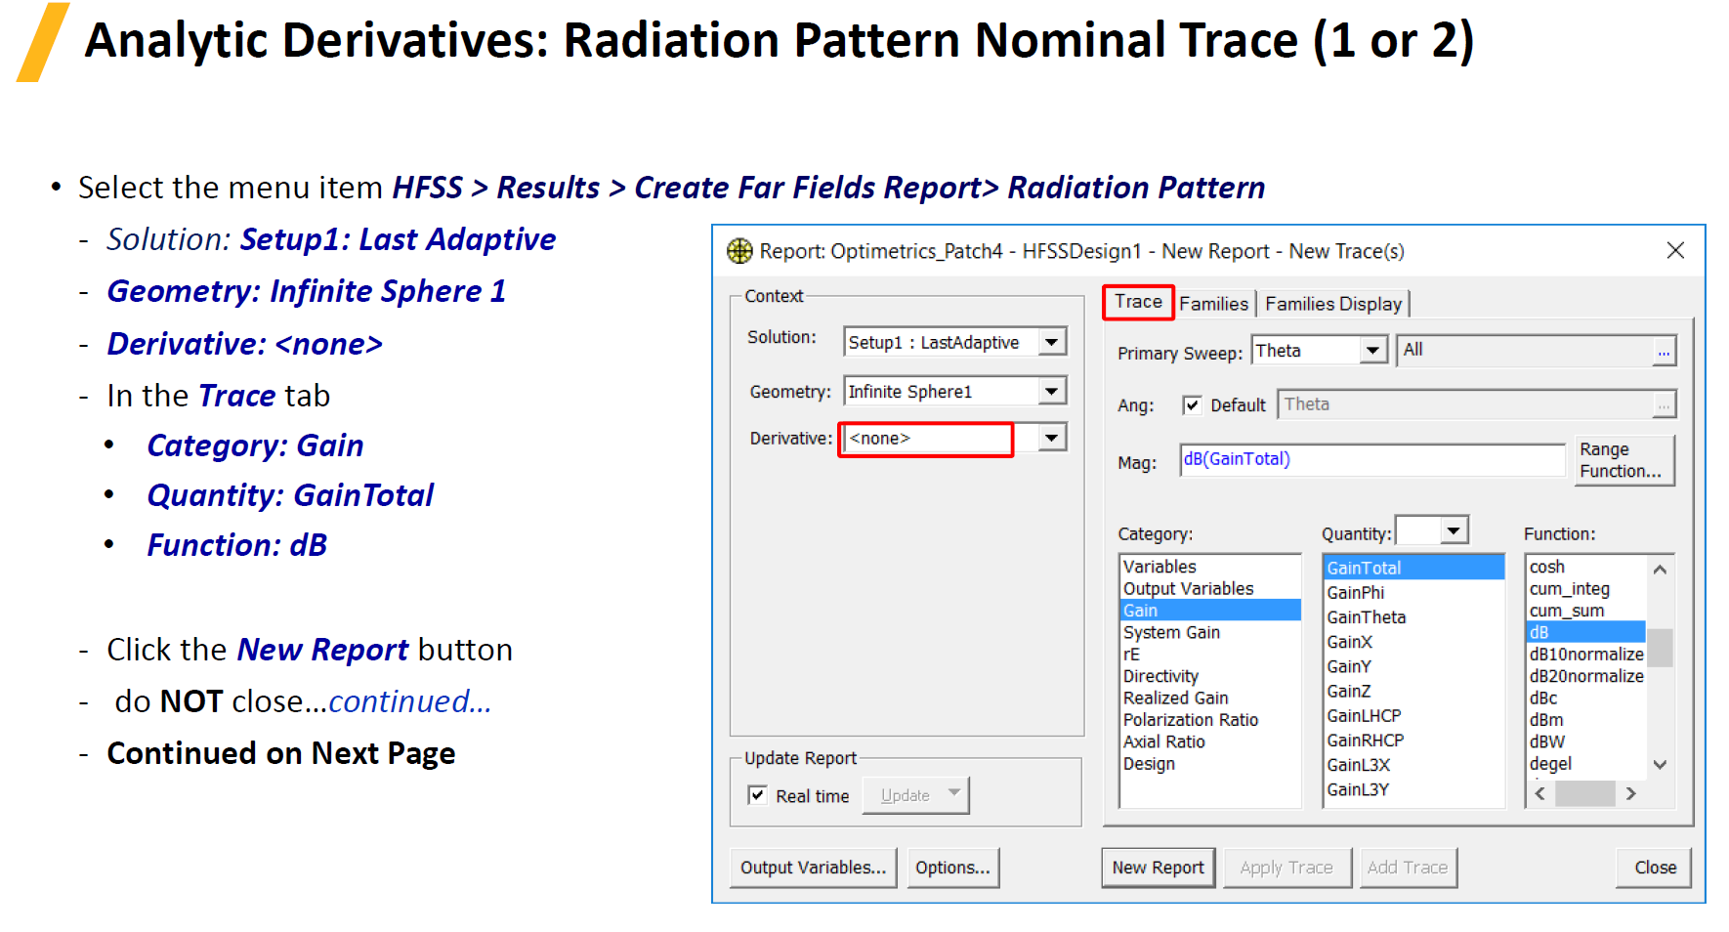

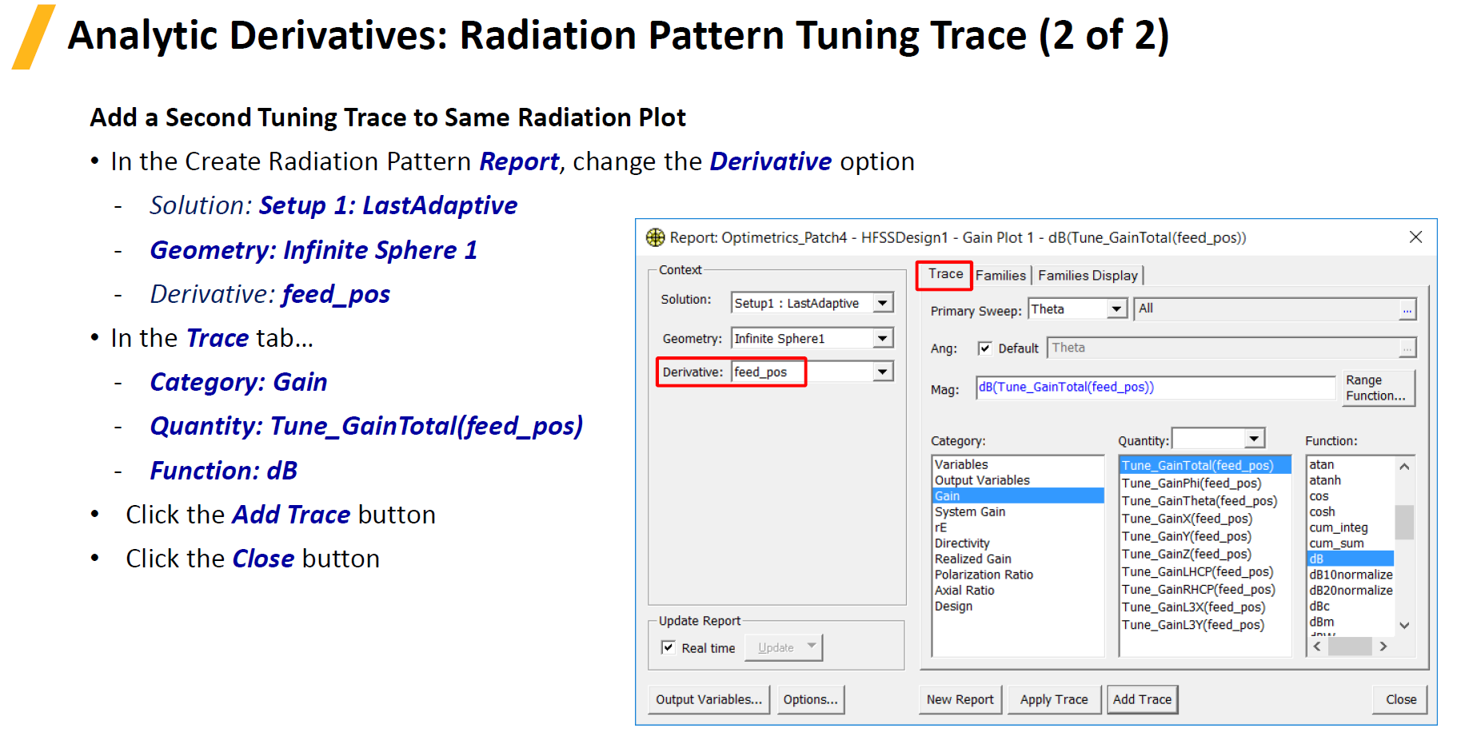

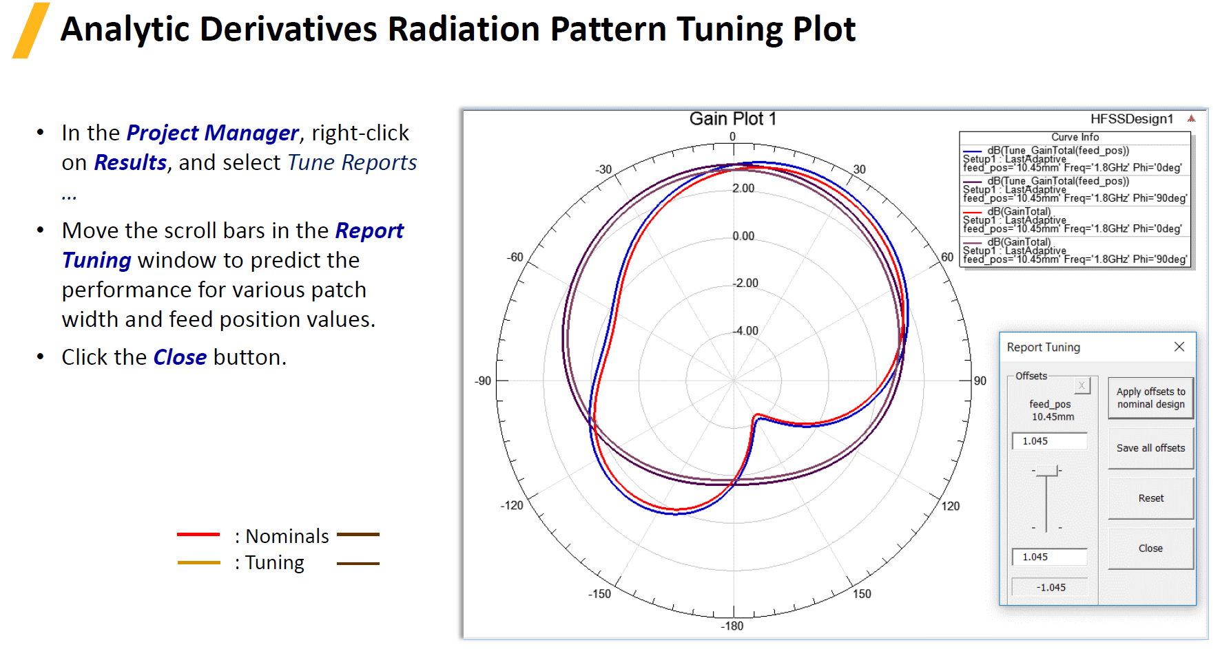

**S- Parameter Results Plot**

With variable feed position



With optimized feed position



Radiation Pattern plot with performance for various patch width and feed position values.



**Observations:**

|  |  |  |  |
| --- | --- | --- | --- |
| **Sl.No** | **Criteria** | **Max Marks** | **Marks obtained** |
| **Data sheet** | | | |
| 1 | Problem statement | 10 |  |
| 2 | Design & specifications | 10 |  |
| 3 | Expected output | 10 |  |
| **Record** | | | |
| 4 | Simulation/ Conduction of the experiment | 15 |  |
| 5 | Analysis of the result | 15 |  |
| 6 | Viva | 40 |  |
| 7 | Total | 100 |  |
| **Scale down to 10 marks** | | | |

**EXPERIMENT 9**

Performance Analysis of Rayleigh Fading Channel Model

**Topic Learning Objectives:**

The student must be able to:

1. Generate a sequence of Identically distributed Rayleigh random variables and plot the histogram for N symbols and compare with Rayleigh PDF.
2. Perform Monte Carlo simulation to estimate and plot the error probability of a BPSK, BFSK and DPSK signaling communication system in Rayleigh fading and compare with theoretical error probability.
3. Compare the probability of error without fading and with Rayleigh fading channel for BPSK, BFSK and DPSK techniques.
4. **AIM:** Performance Analysis of Rayleigh Fading Channel Model using Matlab software.
5. **EQUIPMENTS REQUIRED:** Computer with Matlab software**.**
6. **THEORY:** In all communication systems of practical interest, random effects such as channel noise, interference, and fading, degrade the information-bearing signal as it passes through the system from information source to the final user. Accurate simulation of these systems at the waveform level requires that these random effects be modeled accurately. Therefore, algorithms are required to produce these random effects. The fundamental building block is the random number generator.

A random variable having a uniform probability density function is easily transformed to a random variable having a desired PDF other than uniform. Therefore, the first step in the generation of a random variable having a specified PDF is to generate a random variable that is uniformly distributed on the interval (0,1).

Monte Carlo computer simulations are usually performed in practice to estimate the performance of a digital communication system in the presence of noise and interference. The commonly used metric for the performance of a digital communication system is the probability of error.

1. **PROCEDURE**

The sequential procedure for the performance analysis of Rayleigh fading channel model is as follows.

**4a. Generate a sequence of N=20,000 statistically independent and identically distributed Rayleigh random variables. Plot the histogram for the 20000 symbols and compare it with the corresponding Rayleigh probability density function.**

**Algorithm:**

1. Selectthe number of samples (Ex: N=20,000).
2. Create 1xN matrix of uniform distributed random variables(U)
3. Convert uniform distributed random variable to Rayleigh distributed random variable. Unit variance is assumed.The relation between Rayleigh distributed random variable ‘R’ and uniform distributed random variable U is given by

|  |  |
| --- | --- |
| $$R=\sqrt{-2σ^{2} ln⁡(U)}$$ | (9.1) |

1. Plot the histogram for a given number of samples.
2. Plot the Rayleigh distribution.

The Rayleigh PDF is given by

|  |  |
| --- | --- |
| $$f\left(α\right)=\left\{\begin{matrix}{\frac{α}{σ^{2}}e}^{\frac{{-α}^{2}}{2σ^{2}}} & α≥0 \\ 0 & otherwise\end{matrix}\right.$$ | (9.2) |

1. The expected histogram and Rayleigh PDF for 20,000 samples are shown in fig9.1.



**Fig 9.1: Plots of Histogram and Rayleigh PDF**

**4b. Perform a Monte Carlo simulation to estimate and plot the error probability of a binary antipodal (BPSK) signaling communication system in Rayleigh fading.**

**Algorithm:**

1. Select the energy per bit to 1.
2. Select the signal to noise power in dB.
3. Initialize BER, Number of bits and Number of errors to zero.
4. Assume: m = 0 (All zero code word is transmitted).
5. Create uniform distributed random variable (U)
6. Convert uniform distributed random variable to Rayleigh distributed random variable.Unit variance is assumed.
7. Determine noise voltage using noise power and normally distributed pseudorandom number.
8. Use the expression for input to the detector at the sampling instant to check for the number of errors.

|  |  |
| --- | --- |
| $$y=α\sqrt{E_{b}}cosmπ+n, m=0,1$$ | (9.3) |

If $y≤0$, increment the errors. If $y>0$, errors=0.

1. Determine the BER. $$BER=\frac{Numberoferrors}{Noofbits}$$
2. Calculate error probability using the theoretical formula.

|  |  |
| --- | --- |
| $$P_{e}=\frac{1}{2}\left[1-\sqrt{\frac{{\overline{ρ}}_{b}}{1+{\overline{ρ}}_{b}}}\right]$$ | (9.4) |

Where, $${\overline{ρ}}_{b}=\frac{{2σ^{2}E}_{b}}{N_{0}}$$

The expected results of error probability of a binary antipodal signalling communication system with Rayleigh fading for 10,000 samples are shown in fig 9.2.



**Fig 9.2: Result of Monte Carlo simulation**

**4c. perform a Monte Carlo simulation to estimate and plot the error probability of a binary orthogonal signaling (BFSK) communication system in Rayleigh fading.**

**Algorithm:**

1. Select the energy per bit to 1.
2. Select the signal to noise power in dB.
3. Initialize BER, Number of bits and Number of errors to zero.
4. Assume: m = 0 (All zero code word is transmitted)
5. Create uniform distributed random variable (U)
6. Convert uniform distributed random variable to Rayleigh distributed random variable.Unit variance is assumed.
7. Determine noise voltage using noise power and 1x2 normally distributed pseudorandom numbers.
8. Use the expression for input to the detector at the sampling instant to check for the number of errors.

|  |  |
| --- | --- |
| $$r_{1}= α\sqrt{E_{b}}+n_{1}$$ | (9.5) |
| $$r_{2}=n_{2}$$ |

Where, n1 and n2 are the additive noise components at the outputs of the two correlators.

If $r_{1}$ >= $r_{2}$, number of errors =0. if $r_{1}$ < $r_{2},$ number of errors =1.

1. Determine the BER and Calculation of error probability using the theoretical formula

|  |  |
| --- | --- |
| $$P_{e}=\frac{1}{2}\left[1-\sqrt{\frac{{\overline{ρ}}_{b}}{2+{\overline{ρ}}_{b}}}\right]$$ | (9.6) |

Where, $${\overline{ρ}}_{b}=\frac{{2σ^{2}E}_{b}}{N_{0}}$$

The expected results of error probability of a binary orthogonal signalling communication system with Rayleigh fading for 10,000 samples are shown in fig 9.3.



**Fig 9.3: Result of Monte Carlo simulation**

4d.**Perform a Monte Carlo simulation to estimate and plot the error probability of a DPSK communication systems in Rayleigh fading.**

The other type of binary signal modulation is DPSK. The average probability of error for the signal is given by

|  |  |  |
| --- | --- | --- |
| $$P_{e}=\frac{1}{2\left(1+{\overline{ρ}}_{b}\right)}$$ | DPSK | (9.7) |

The probability of error without fading for BPSK, BFSK and DPSK are respectively given by

|  |  |  |
| --- | --- | --- |
| $$P_{e}=Q\left(\sqrt{\frac{2E_{b}}{N_{0}}}\right)$$ | BPSK | (9.8) |
| $$P_{e}=\frac{1}{2}e^{- \frac{E_{b}}{2N_{0}}}$$ | BFSK | (9.9) |
| $$P_{e}=\frac{1}{2}e^{- \frac{E_{b}}{N_{0}}}$$ | DPSK | (9.10) |



**Fig 4: Performance of binary signaling without fading and with Rayleigh fading channel**

The comparison plot of probability error with fading and without fading is shown in fig 4. The aspects of these graphs in fading channel are the slow decay of the probability of error as a function of SNR. This is in contrast to the exponential decrease in the case of the AWGN channel.

Codes:

AWGN FADING

clc;

close all;

N=20000;

SNR_limit=35;

SNR_db=-5:0.5:SNR_limit;

SNR=10.^(SNR_db/10);

u=rand(1,N);

m=floor(2*rand(1,N));

var=1; % sigma^2

nstd=sqrt(var);

y=(zeros(1,N));

Pe_BPSK_sim=(zeros(1,length(SNR)));

Pe_BFSK_sim=(zeros(1,length(SNR)));

Pe_DPSK_sim=(zeros(1,length(SNR)));

%4(a)generate rayleighranom variable

r=sqrt(-(2*var*log(u)));

Fig(1);

hist(r,100);

title('rayleigh random variable histogram plot');

xlabel('random variable R');

ylabel('frequency')

a=[0:0.01:10];

R=(a/var).*exp(-(a.*a)/(2*var));

Fig(2);

plot(a,R);

title('rayleigh PDF');

xlabel('random variable');

ylabel('probability');

legend('variance =1')

%BPSK simulation

Pe_BPSK_id=0.5*(1-sqrt((var*SNR)./(1+var*SNR)));

%BFSK simulation (coharent)

BFSK_id = 0.5*(1-sqrt(var*SNR./(2+(var*SNR))));

%DPSK simulation

Pe_DPSK_id=0.5./(1+var*SNR);

%Comparison of Error performance for AWGN and rayleigh fading channels

Pe_BPSK_NF=0.5*(erfc(sqrt(SNR)));

Pe_BFSK_NF=0.5*(erfc(sqrt(SNR/2)));

Pe_DPSK_NF=0.5*exp(-SNR); %non-coharent

Fig(3);

semilogy(SNR_db,Pe_BPSK_id,'r.-', SNR_db,BFSK_id,'r*-',SNR_db,Pe_DPSK_id,'r--', SNR_db,Pe_BPSK_NF,'b.-',SNR_db,Pe_BFSK_NF,'b*-',SNR_db,Pe_DPSK_NF,'b--');

axis([-5 SNR_limit 0.000001 1]);

title('performance of BPSK,BFSK,DPSK')

xlabel('SNR(db)');

ylabel('probability of error');

legend('Pe of BPSK with fading','Pe of BFSK with fading','Pe of DPSK with fading','Pe of BPSK without fading','Pe of BFSK without fading','Pe of DPSK without fading');

****************************************************************************************************************************************************************************

BFSK

clc;

close all;

N=20000;

SNR_limit=35;

SNR_db=-5:0.5:SNR_limit;

SNR=10.^(SNR_db/10);

u=rand(1,N);

m=floor(2*rand(1,N));

var=1; % sigma^2

nstd=sqrt(var);

y=(zeros(1,N));

Pe_BPSK_sim=(zeros(1,length(SNR)));

Pe_BFSK_sim=(zeros(1,length(SNR)));

Pe_DPSK_sim=(zeros(1,length(SNR)));

%4(a)generate rayleighranom variable

r=sqrt(-(2*var*log(u)));

Fig(1);

hist(r,100);

title('rayleigh random variable histogram plot');

xlabel('random variable R');

ylabel('frequency')

a=[0:0.01:10];

R=(a/var).*exp(-(a.*a)/(2*var));

Fig(2);

plot(a,R);

title('rayleigh PDF');

xlabel('random variable');

ylabel('probability');

legend('variance =1')

%BPSK simulation

Pe_BPSK_id=0.5*(1-sqrt((var*SNR)./(1+var*SNR)));

%BFSK simulation (coharent)

BFSK_id = 0.5*(1-sqrt(var*SNR./(2+(var*SNR))));

%DPSK simulation

Pe_DPSK_id=0.5./(1+var*SNR);

%Comparison of Error performance for AWGN and rayleigh fading channels

Pe_BPSK_NF=0.5*(erfc(sqrt(SNR)));

Pe_BFSK_NF=0.5*(erfc(sqrt(SNR/2)));

Pe_DPSK_NF=0.5*exp(-SNR); %non-coharent

Fig(3);

semilogy(SNR_db,Pe_BPSK_id,'r.-', SNR_db,BFSK_id,'r*-',SNR_db,Pe_DPSK_id,'r--', SNR_db,Pe_BPSK_NF,'b.-',SNR_db,Pe_BFSK_NF,'b*-',SNR_db,Pe_DPSK_NF,'b--');

axis([-5 SNR_limit 0.000001 1]);

title('performance of BPSK,BFSK,DPSK')

xlabel('SNR(db)');

ylabel('probability of error');

legend('Pe of BPSK with fading','Pe of BFSK with fading','Pe of DPSK with fading','Pe of BPSK without fading','Pe of BFSK without fading','Pe of DPSK without fading');

***********************************************************************************************************************************************************************

BPSK

%%Performance of Binary Modulation in Rayleigh Fading Channel

%%transmission through a frequency nonselective channel

clc;

Eb= 1; % Energ per bit

EbNo_dB= 0:5:35 % vary the average SNR

No_over_2= Eb*10.^(-EbNo_dB/10)% Noise power

sigma= 1 ; % Rayleigh parameter

var=sigma^2;

BER= zeros(1,length(EbNo_dB));

% Calculation of error probabilit using Monte Carlo simulation:

for i = 1:length(EbNo_dB)

no_errors = 0;

no_bits = 0;

% Assumption: m = 0 (All zero codeword is transmitted):

while no_errors <= 10

u = rand;

% rand returns a single uniformly distributed

%random number in the interval (0,1)

alpha = sigma*sqrt(- 2*log(u)) ; % alpha is non-negative

%Rayleigh distrbuted with variance selected to be unity.

noise = sqrt(No_over_2(i))*randn; %randn gives Gaussian, with zero mean and unit variance

y = alpha*sqrt(Eb) + noise; %simulate the input to the detector

if y <= 0

y_d = 1;

else

y_d = 0;

end

no_bits = no_bits + 1 ;

no_errors = no_errors + y_d;

end

BER(i) = no_errors/no_bits ;%estimated error probability

end

% Calculation of error probabilit using the theoretical formula:

rho_b = Eb./No_over_2*var;

P2 = 1/2*(1-sqrt(rho_b./(1+rho_b))); %the theoretical value

% Plot the results:

semilogy(EbNo_dB,BER, '-* ' ,EbNo_dB, P2,'-o')

title('Montecarlosimualtion for Performance of BPSK signal');

xlabel('Average SNR/bit (dB)')

ylabel('Error Probability')

legend('Monte Carlo simulation','Theoretical value')

**Observations:**

|  |  |  |  |
| --- | --- | --- | --- |
| **Sl.No** | **Criteria** | **Max Marks** | **Marks obtained** |
| **Data sheet** | | | |
| 1 | Problem statement | 10 |  |
| 2 | Design & specifications | 10 |  |
| 3 | Expected output | 10 |  |
| **Record** | | | |
| 4 | Simulation/ Conduction of the experiment | 15 |  |
| 5 | Analysis of the result | 15 |  |
| 6 | Viva | 40 |  |
| 7 | Total | 100 |  |
| **Scale down to 10 marks** | | | |

**EXPERIMENT 10**

**Simulation of OFDM Transmitter and Receiver**

**Topic Learning Objectives:**

The student must be able to:

1. Perform simulation of OFDM transmitter and receiver and to estimate BER and compare with theoretical BER.
2. Compare the SNR vs BER for different subcarriers of OFDM.
3. **AIM:** Performance Analysis of OFDM Transmitter and Receiver using Matlab software.
4. **EQUIPMENTS REQUIRED:** Computer with Matlab software**.**
5. **THOERY:**

Orthogonal frequency-division multiplexing (OFDM) is a method of encoding digital data on multiple carrier frequencies. OFDM has developed into a popular scheme for [wideband](https://en.wikipedia.org/wiki/Wideband) [digital communication](https://en.wikipedia.org/wiki/Digital_communication), used in applications such as digital television and audio broadcasting, [DSL](https://en.wikipedia.org/wiki/Digital_subscriber_line) [Internet access](https://en.wikipedia.org/wiki/Internet_access), [wireless networks](https://en.wikipedia.org/wiki/Wireless_network), [power line networks](https://en.wikipedia.org/wiki/Power-line_communication), and [4G](https://en.wikipedia.org/wiki/4G) mobile communications.

It is the multi carrier system for communication of information over wireless channels. The important advantage is, higher rate information is converted into a group of parallel lower- rate information. The complexity of receiver construction is reduced because frequency-selective fading channel is transformed into a group of similar flat fading sub channels. Orthogonality is introduced between subcarriers in time, however in the frequency domain the spectra of these subcarrier overlap. So, there is effective bandwidth utilization in OFDM systems avoid of ICI as given in Fig 1.

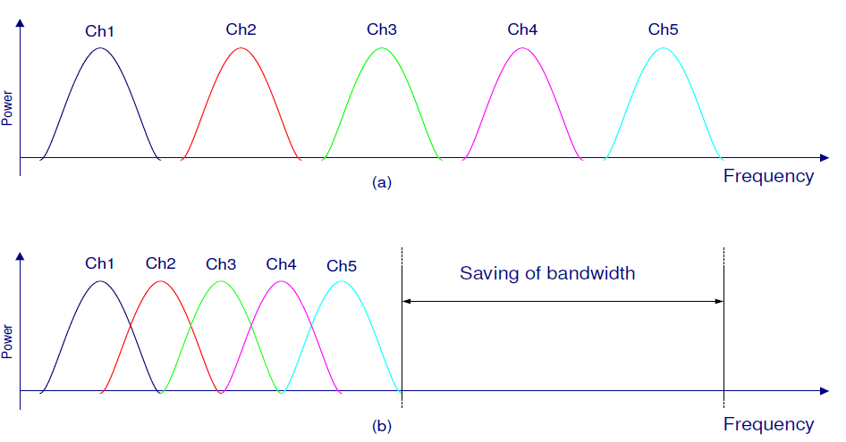

## Fig 1

High data rate composite signal is obtained by combining low data rate subcarriers with large symbol time. This mitigates the effect of ISI which frequently happens with signals of short symbol duration in a multipath environment. OFDM is a multicarrier modulation as defined in equation1.OFDM baseband signal with ‘n' point IFFT signal processing is equivalent to the summation of n multiple components of sinusoids.

|  |  |
| --- | --- |
|  |  |
|  | (10.1) |

1. Where $n=0 to N-1 and x(k)$ = data symbol which is in complex number. The baseband OFDM signal after IFFT is expressed in time domain as follows;

|  |  |
| --- | --- |
|  |  |
|  | (10.2) |
|  |  |

And $NT$ is the time duration of OFDM symbol which consists of discrete $N$ time slots each of which has $T$ time duration. The real part and imaginary part of base-band OFDM signal are multiplied $cosw_{c}t$ by and $sinw_{c}t$ respectively.

1. Therefore, the pass band OFDM signal is expressed as follows;

|  |  |
| --- | --- |
|  | (10.3) |

1. And $\sqrt{x_{Re}^{2}\left[nT\right]+x_{Im}^{2}\left[nT\right]}$ means the envelope of the passband OFDM signal in each discrete time slot.

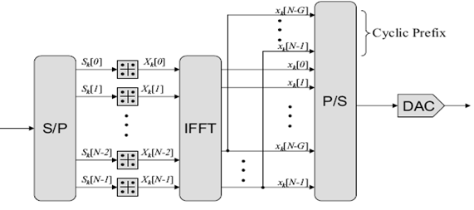(10.4)

1. Fig 2 (a). Block diagram of OFDM Transmitter
2. 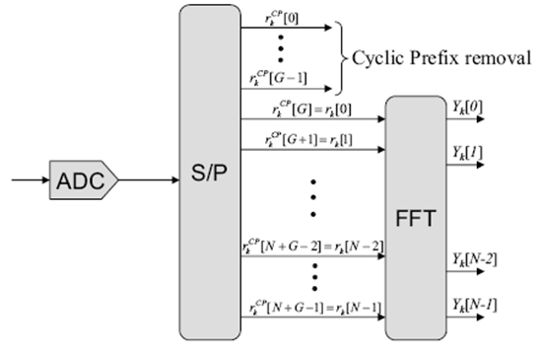(10.5)
3. Fig 2 (b). Block diagram of OFDM Receiver

The key challenge in the realization of OFDM was the requirement of a many sinusoidal generators at the transmitter and many filters at the receiver. These problems could be resolved using IFFT and FFT at the transmitter and receiver respectively. In OFDM wide-band signal is split into several orthogonal narrow band signals. For this purpose, a high data rate data stream is divided into 𝑁 parallel low-rate data stream, 𝑋𝑘 = 1 to𝑁, as shown in Fig 2(a). IFFT is used to modulate the orthogonal narrow band signals.

In order to eliminate ISI a guard interval is added between OFDM symbols and it should be larger than delay spread. A cyclic prefix is included in the guard interval. After passing though parallel to serial converter OFDM symbols are modulated with a high frequency carrier. As shown in the Fig 2b, the reverse action is performed to reconstruct the high-rate data stream at the receiver.

## ALGORITHM:

* 1. Generation of random binary sequence
  2. BPSK modulation i.e bit 0 represented as -1 and bit 1 represented as +1
  3. Assigning to multiple OFDM symbols to data
  4. Add cyclic prefix and concatenate symbols to form a long transmit sequence.
  5. Generate AWGN using Random signal.
  6. Demodulated data output
  7. Compare Input Data Stream and Demodulated Output Data.
  8. Make the decision on the received data bits
  9. Set the appropriate threshold level and compare it with the demodulated data. Grouping the received vector into multiple symbols, removing cyclic prefix, taking the desired subcarriers.
  10. Compute the number of errors and plot the SNR vs BER
  11. Vary the number of subcarriers and plot the theoretical and practical BER

Sample outputs:

Number of subcarriers =64



Number of subcarriers =128

**MATLAB CODE**

clear all

nFFT = 64; % fft size

nDSC = 52; % number of data subcarriers

nBitPerSym = 52; % number of bits per OFDM symbol (same as the number of subcarriers for BPSK)

nSym = 10^4; % number of symbols

EbN0dB = [0:10]; % bit to noise ratio

EsN0dB = EbN0dB + 10*log10(nDSC/nFFT) + 10*log10(64/80); % converting to symbol to noise ratio

for ii = 1:length(EbN0dB)

% Transmitter

ipBit = rand(1,nBitPerSym*nSym) > 0.5; % random 1's and 0's

ipMod = 2*ipBit-1; % BPSK modulation 0 --> -1, 1 --> +1

ipMod = reshape(ipMod,nBitPerSym,nSym).'; % grouping into multiple symbolsa

% Assigning modulated symbols to subcarriers from [-26 to -1, +1 to +26]

xF = [zeros(nSym,6) ipMod(:,[1:nBitPerSym/2]) zeros(nSym,1) ipMod(:,[nBitPerSym/2+1:nBitPerSym]) zeros(nSym,5)] ;

% Taking FFT, the term (nFFT/sqrt(nDSC)) is for normalizing the power of transmit symbol to 1

xt = (nFFT/sqrt(nDSC))*ifft(fftshift(xF.')).';

% Appending cylic prefix

xt = [xt(:,[49:64]) xt];

% Concatenating multiple symbols to form a long vector

xt = reshape(xt.',1,nSym*80);

% Gaussian noise of unit variance, 0 mean

nt = 1/sqrt(2)*[randn(1,nSym*80) + j*randn(1,nSym*80)];

% Adding noise, the term sqrt(80/64) is to account for the wasted energy due to cyclic prefix

yt = sqrt(80/64)*xt + 10^(-EsN0dB(ii)/20)*nt;

% Receiver

yt = reshape(yt.',80,nSym).'; % formatting the received vector into symbols

yt = yt(:,[17:80]); % removing cyclic prefix

% converting to frequency domain

yF = (sqrt(nDSC)/nFFT)*fftshift(fft(yt.')).';

yMod = yF(:,[6+[1:nBitPerSym/2] 7+[nBitPerSym/2+1:nBitPerSym] ]);

% BPSK demodulation

% +ve value --> 1, -ve value --> -1

ipModHat = 2*floor(real(yMod/2)) + 1;

ipModHat(find(ipModHat>1)) = +1;

ipModHat(find(ipModHat<-1)) = -1;

% converting modulated values into bits

ipBitHat = (ipModHat+1)/2;

ipBitHat = reshape(ipBitHat.',nBitPerSym*nSym,1).';

% counting the errors

nErr(ii) = size(find(ipBitHat - ipBit),2);

end

simBer = nErr/(nSym*nBitPerSym);

theoryBer = (1/2)*erfc(sqrt(10.^(EbN0dB/10)));

close all; Fig

semilogy(EbN0dB,theoryBer,'bs-','LineWidth',2);

hold on

semilogy(EbN0dB,simBer,'mx-','LineWidth',2);

axis([0 10 10^-5 1])

grid on

legend('theory', 'simulation');

xlabel('Eb/No, dB')

ylabel('Bit Error Rate')

title('Bit error probability curve for BPSK using OFDM')

CONCLUSION:

**Observations:**

|  |  |  |  |
| --- | --- | --- | --- |
| **Sl.No** | **Criteria** | **Max Marks** | **Marks obtained** |
| **Data sheet** | | | |
| 1 | Problem statement | 10 |  |
| 2 | Design & specifications | 10 |  |
| 3 | Expected output | 10 |  |
| **Record** | | | |
| 4 | Simulation/ Conduction of the experiment | 15 |  |
| 5 | Analysis of the result | 15 |  |
| 6 | Viva | 40 |  |
| 7 | Total | 100 |  |
| **Scale down to 10 marks** | | | |

**APPENDIX 1**

Sample Calculation to Determine Various Parameter of Reflex Klystron

1. Knowing mode top voltage of two adjacent modes, mode number of the modes may be computed from equation below,
$$\frac{N_{2}}{N_{1}}=\frac{V_{1}}{V_{2}}=\frac{\left(n+1\right)+\frac{3}{4}}{n+\frac{3}{4}}$$

2. Knowing mode number, transit time of each mode may be calculated from equation below
$$t_{1}=\frac{n+\frac{3}{4}}{f_{01}}=\frac{N_{1}}{f_{01}} sec$$

3. Calculate electronic tuning range i.e., the frequency band from one end of the mode to another.
4. Electronics Tuning Sensitivity (ETS) may be calculated from equation below,

f2 and f1 being half power frequencies in GHz, and V2 and V1 are corresponding voltages for particular mode. A practical example is given below

$\frac{N_{1}}{N_{2}}=\frac{n+\frac{3}{4}}{\left(n+1\right)+\frac{3}{4}}=\frac{V_{2}}{V_{1}}\left(or\right)\frac{n+0.75}{n+1.75}=\frac{-64}{-105.5}\left(or\right),n=\frac{32.9}{40.5}≅1$

1. Hence, N1=1.75 and N2=2.75 are the respective mode numbers. Corresponding transit times are:

$$t_{1 }=\frac{N_{1}}{f_{01}}=\frac{1.75}{9.465}×{10}^{-9 }=1.8 ×{10}^{-8} s$$

$$t_{2 }=\frac{N_{2}}{f_{02}}=\frac{2.75}{9.47}×{10}^{-9 }=2.9 ×{10}^{-8} s$$

$ETR for 1.75 mode =\left(9.488-9.435\right) ×{10}^{9}=53 Hz$

$$ETR for 2.75 mode = \left(9.482-9.435\right) ×{10}^{9}=53 Hz$$

$ETS for 1.75 mode=\frac{f_{2- }f_{1}}{V_{2}-V_{1}}=\frac{(9.485-9.39)}{(111.5-98)} ×{10}^{9}\frac{Hz}{V}=\frac{46}{13.5}=3.4 MHz/V$

$ETS for 2.75 mode=\frac{f_{2- }f_{1}}{V_{2}-V_{1}}=\frac{(9.487-9.482)}{(69-57.5)} ×{10}^{9}\frac{Hz}{V}=\frac{45}{11.5}=3.9 MHz/V$

**APPENDIX 2**

Definitions of Microwave Parameters

The parameters that define Directional coupler are

**Coupling factor, C:** it is defined as the ratio of the incident power Pi to the forward power Pr measured in dB. Coupling factor is a measure of how much of the incident power is being sampled while directivity is the measure of how well the directional coupler distinguishes between the forward and reverse travelling powers.

$C=10\log_{10}\frac{P_{i}}{P_{f}}$ dB (1)

**Directivity, D:** the directivity is defined as the ratio of forward power Pf to the back power Pb, expressed in dB.

$D=10\log_{10}\frac{P_{f}}{P_{b}}$ dB (2)

**Isolation, I:** it is defined to describe the directive properties of a directional coupler. It is defined as the ratio of incident power Pi to the back power Pb.

$I=10\log_{10}\frac{P_{i}}{P_{b}}$ dB (3)

Isolation in dB is equal to the coupling factor plus directivity.

As with any component or system, there are several specifications associated with RF directional couplers. The major RF directional coupler specifications are summarized in the table below.

|  |  |
| --- | --- |
| **Term** | **Description** |
| **Coupling Loss** | Amount of power lost to the coupled port (3) and to the isolated port (4). Assuming a reasonable directivity, the power transferred unintentionally to the isolated port will be negligible compared to that transferred intentionally to couple port. |
| **Main line loss** | Resistive loss due to heating (separate from coupling loss). This value is added to the theoretical reduction in power that is transferred to the coupled and isolated ports (coupling loss). |
| **Directivity** | Power level difference between Port 3 and Port 4 (related to isolation). This is a measure of how independent the coupled and isolated ports are. Because it is impossible to build a perfect coupler, there will always be some amount of unintended coupling between all the signal paths. |
| **Isolation** | Power level difference between Port 1 and Port 4 (related to directivity). |

**Vision**

Imparting quality technical education through interdisciplinary research, innovation and teamwork for developing inclusive & sustainable technology in the area of Electronics and Communication Engineering.

**Mission**

* To impart quality technical education to produce industry-ready engineers with a research outlook.
* To train the Electronics & Communication Engineering graduates to meet future global challenges by inculcating a quest for modern technologies in the emerging areas.
* To create centers of excellence in the field of Electronics & Communication Engineering with industrial and university collaborations.
* To develop entrepreneurial skills among the graduates to create new employment opportunities.